Correspondence with Dr. James Gray 2006 – 2007

Photos sent to Dr. James Gray via the Sterling Allen Free Energy Site sometime in early March 2006

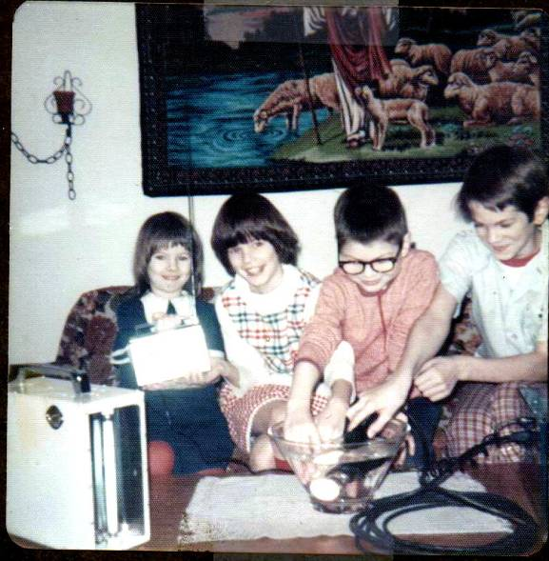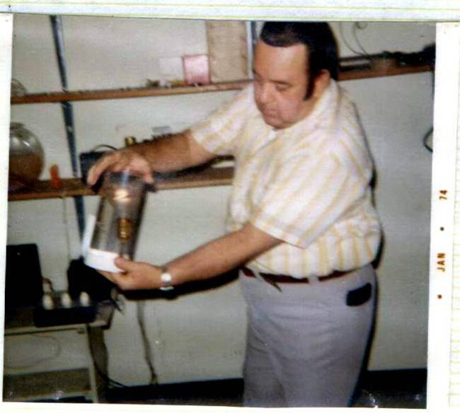

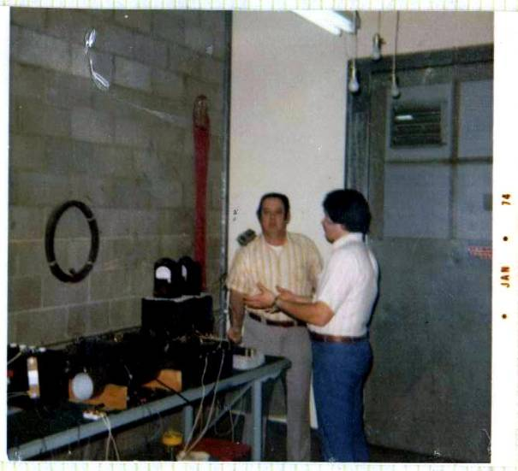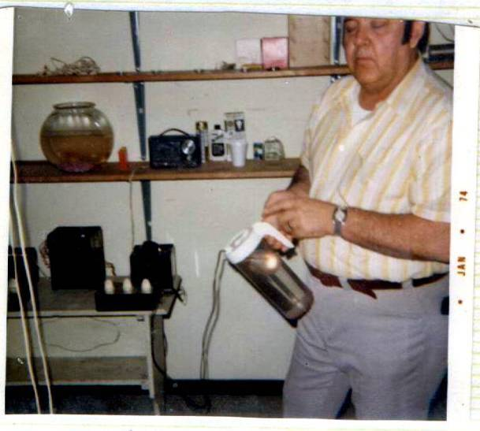

Dr. Gray had sent a number of emails to Mr. Sterling concerning his experiences with his father E. V. Gray in and around 1973. Mr. Sterling had consolidated a number of these emails from family members into one article that he featured on his web site that year. I decided to attempt to contact Dr. Gray via the web site and communicate with him directly. I was hoping that additional technical information, no matter how minor, could be disclosed.

These photos came from the GD collection that had just become available that year. I thought that these family photos would have more impact and be more interesting than equipment photos. At the time I didn’t know that the photos of the children were in fact GD’s family and not anyone related to E.V. Gray.

As I recall I received a response from Dr. Gray, who had confused me with someone else from Spokane who had spoken with him on the phone. The following are the emails we shared in the following months.

From: Dr. James A. Gray, Sr. [mailto:icyams@sbcglobal.net]
Sent: Tuesday, March 14, 2006 11:45 AM
To: Mckay, Mark
Subject: Just looking . . .
Hello Mark McKay,

I've reading-up on many articles regarding my father's (Edwin V. Gray, Sr.) invention (the "EMA" motor), and through my journey of endless literature, some good, some bad, some on target, some out in left field and some that are pointless emotional dribble . . . and few folks that are sincerely attempting to find those seemingly missing pieces which made his motor(s) complete. I pray that someone will turn-up that mysterious missing link that will complete the cycle of operations.

As I have stated, my journeyed has now lead me to your name, and I wonder what you are doing, and/or attempting to do with this technology? Also, a few years ago, after the Saturn EV-1 was disenfranchised from GM's line of discoveries, I had contacted someone in Spokane, Washington for knowledge of the hidden motor which powered the Saturn EV-1.I was told by this individual of on-going rework of this motor, in fact, I was e-mailed several pictures of the motor. I still have them.

My question is, are you the person I spoke with? If so, how are you doing with your pursuit? Anything coming together as yet? I'd love to know if you have made any headway!

Sincerely submitted,

Dr. James A. Gray, Sr.
================================================================================

Dr. James A. Gray, Sr.
"Prayerful Solutions!"
Christian Counseling Services
1335 N. Caddy Lane
Wichita, KS 67212
(316) 641-7029

Tue 3/14/2006 11:55 AM

Dear Dr. Gray

I am the individual that sent you the photo of the children whom you said were not your siblings, even though they were still cute. This was just a month ago in care of the Sterling Allen site. I also sent you three more photos of your father doing some demonstrations around 1973. Did those last three photos arrive? I have additional photos that you might be interested in. These photos are from a former investor who requested that they not be circulated on the internet.

I don't have any information about the Saturn EV-1 project. If there is a person in Spokane that has such knowledge I would certainly like to make contact with them. Other than the two e-mails I sent you recently, I don't believe we have had the pleasure of communicating before this time.

As far a technical progress, my area of focus right now is to determine the dynamic physics of the "Floating Flux Field". There is so much similarity between this unique component and the John Bedini Monopole pulse motors that a serious investigation is warranted. As you know, your father didn't revel the complete non-classical energy process in his patent documents, however I feel there are many vital clues disclosed that need to be explored. There is more technical information available on the Bedini Monopole motor than the "FFF". My aim is to extract the core process that John is using in his motors and see how( or "if") it applies to the equipment configuration your father used in the EMA4-E1 motor. See attached paper.

Mean while, Carl Lennon of Florida [cllennon@earthlink.net] is actively working on researching the operation of the "Converter Switching Element Tube" (CSET). He is a retired EMI electrical engineer
who worked for NASA. He really knows his stuff in this area. He recently published an article in "Electric Spacecraft Journal". If you like I can send you a scanned copy of this article.

Dr. Peter Lindemann and John Bedini are doing product development just down the freeway in Post Falls. I occasionally have lunch with Peter and share his insights on his current research at least to the level of my limited understanding. It appears they are making technical progress with the Bedini technology, but the central fundamental physics is anybodies guess. Mr. Bedini refers the theory to Mr. Tom Bearden, who has a whole collection of related ideas on this subject. But, Tom is very short on experimental verification of these theories.

There are a couple of chat rooms on Yahoo.com that claim to focus on EV Gray technology, but I am generally disappointed in the subject material they discuss.

I have been doing a good deal of writing (for me anyway) these past few months about your fathers technology. I'm attempting to collect as many technical facts and observations as possible. If not to solve the riddle at least to pass it on to current and future researchers. This effort might result in a small self published technical book.

I have recently completed one paper about your father's involvement with "Boot" Mallory and the Mallory Electric Company of Carson City Nevada that I would very much like you to review and check for historical accuracy. I could e-mail it to you, but with the drawings and photos it is 13 MB in size, most e-mail services can't handle that large of file. Since you have included your address I shall just send you a CD of the documents I have written to date for your review and to add to your files. If they meet with your approval feel free to distribute them to anyone.

Thank you so very much for contacting me.

Mark McKay, PE

Wed 3/15/2006 3:07 PM

Dear Mark,

I find myself being pulled into the study and research of my father's original "EMA" invention and it's applications! I so wish that he would have allowed me to be privy to his technologies . . . however, he didn't! He didn't for reasons that most folks might find bizarre. That's why I have never discussed them with anyone previously. These reasons have absolutely nothing to do with his being "distrustful" and "suspect" of others as some have theorized along the way either. As well, it'll serve no real purpose in the attempt to corrall the many folks who are (like yourself) trying to recreate the missing-link that will make this whole journey worthwhile! If it weren't for the fact that whomever may finally connect-the-dots correctly on this device, and could conceivably make an ungodly fortune in both fame and finances . . . I'd try, even in vein to bring all people together at one table of sharing ALL experiences and experiments!
Somehow, somewhere, someway, the answer to my father's ill managed secrets to re-complete his marvelous motor will, no, MUST be found!

Let me ask you something? Do you think, in all sincerity that I might be able, by the grace of God . . . to petition all those folks to come together under one canopy of collective effort to pool our knowledge for the chance of actually re-establishing the ONE COMMON GOAL OF FINISHING THIS PROJECT WHICH THE WORLD SO DESPARATELY NEEDS?! I have been praying for a solution to redeem everyone's efforts and contributions to the final resolve . . . A TRUE WORKING "EMA" MOTOR! I believe the answer lies out there, and if all participants could/would come together for a "summit" on all existing technologies regarding the original motor and it's applications! This invention is of ultimately important to the future of this planet and humanity! I sense an urgency for a grand scale coming together of minds and hearts. I truly believe that God will redeem the honesty and integrity of each one who comes in the name of science for making a better tomorrow!

Mark, I'll now address the various issues mentioned in your response below:

1st, I would indeed enjoy viewing more photos, whatever you may have . . . please? And no I did not receive any other pictures. In your circle of friends/investors, you might inquire to see if any of them know of me. Also, I'd invite others to correspond with me in hopes of gaining more insight to an area where I was kept in the dark. Some day I intend to put together a autobiography of my father, his 1st and 2nd family, his invention the days leading up to his death and beyond. But only if I can gather enough missing information between the years of parents divorce and his untimely death. A second issue is also in the making surrounding the discrepancies and circumstances of his death and on up to current.

2nd, Regarding the "EV-1 Saturn" by GM, I've got it around here somewhere and soon as I can locate this fellow, I'll send the info to you . . . pictures too.

3rd, Electrical and electronic design works have always intrigued and fascinated me throughout my life, but I have very basic knowledge to work with. Your work peaks my curiosity, I'd like to read-up and learn more . . . so I'll try! The "attached" paper is a hand full for me at the moment, but I believe I understand it to a point! I marvel at folks like you, and how these ideas click in your minds! I used to be this way with mechanical applications, but I've been away from those forms and processes for an awful long time. There have been many a times when I wished to be back in the design field!

4th, How well do you know Carl Lennon of Florida? It seems as though this is the area of most interest, the assembly least understood. Am I correct? Is this the assembly attached to the front-end of the motor? What exactly was the function of the "Converter Switching Element Tube"? Did this mechanism convert D/C to A/C current, or what" I've been thinking about this portion, it seems to be bouncing around in my head. Tell me more of it's function. Who knows, maybe the answer is locked-up inside me too! Odder things have happened in the name of science! Consider, my father had an 8th grade education, yet, he was a fabulous designer/fabricator, especially with mechanical applications! I remember when he started getting these ideas for this motor (we lived in Las Vegas, Nevada), my brother
Eddie and I would watch him put pieces of odds-n-ends together, and bit-by-bit it would start to look like something we'd never seen before! Oh sure, he'd tell what he was trying to accomplish . . . but all his verbal impartations (explanations) were purely foreign language to us at the time! Some times his experiments were a dud, some times they'd catch fire, and some times explode . . . and we'd all run like

the dickens to find cover!! Whew! rather these experiments worked at first or not . . . he'd simply clean-up and start over as soon as he could find some free time! Actually, Dad would disconnect any electrical supply (if there was any involved), then my brother and I were given the (as my father called it: OPPORTUNITY) to clean-up his mess! Actually, we had a lot of fun! Anyway, before I wax to far the off-track, the realm of science that you and Carl Lennon occupy are is a space and dimension that I dream
of! I hope to learn more from you . . .

5th, As I recall, Peter Lindemann was on the inner-circle with my father from the early 70's, and on . . . till my father's death! I believe my brother Eddie had some communications with him even afterwards. I remember meeting him on a few occasions at the shop/lab, on Calvert Street in Van Nuys, California, and seeing him a few other times . . . such as the "Premier" in Studio City, CA (1-91976). I'm surprised he doesn't know more about the "EMA" apparatus and it's various parts and assemblies! I would have thought him to be in possession of one the complete machines! Well, anyway, what's he working on these days, especially regarding varying applications of my father's invention(s)? next time you see him, ask him if he remembers me (the 2nd son with Rheumatoid Arthritis), and inform him that I'd love to hear from him, and, be updated works! Sincerely.

6th, The fellow which Peter is working with, John Bedini, I'm not familiar with him, nor their joint venture into physics. Just what are these two attempting to uncover/discover? You know, I'll never understand why so many folks who tinker in the sciences are so slow to write down in detail every step of their theories and/or experimentations! Perhaps it's fear of failure, fear of success, or, perhaps it's simple
scientific dysfunctionalism! Well, there is one other, and that has to do libido (ego)! It gives to those around them a air of mystique! Thus, folks like this, folks like my father . . . thrive on the attention, and the so much ado over them (personally)! Unfortunately, if they have anything actually on-the-ball, critical elements, procedures, formulas, etc. are lost . . . perhaps forever! Say, what is the theory of Tom Bearden all about?

7th, I've never been a fan of "chat-rooms."

8th, Mark, I am very interested in reading you findings regarding "Boot" Mallory and the Mallory Electric Company of Carson City, Nevada. It would also be my extreme pleasure to review your literary work concerning the historical accuracy of this passage of time. In a final thought (for now), I just called the man who updates and maintenances my p/c system, he says that my e-mail program should receive a 13MB file, however, should you choose to try sending your "works" in this manner, he suggests that you also send it to his e-mail address too: mcmercer@gmail.com for safety's sake. He will in-turn burn it onto a CD for my use and files. On the other hand, you may select to "post" a CD to my "snail-mail" address as listed:
Dr. James A. Gray, Sr.
1335 North Caddy Lane
Wichita, Kansas 67212

9th, Mark, should you ever desire to chat via the telephone, my telephone number is: 316-641-7029 . . . personally, I would be delighted to make a new friend. As well, we both have two common interests . . . my father and, the "EMA" motor!

Sincerely, James A. Gray, Sr.

Wed 3/15/2006 5:12 PM

Dear James,

Thank you so very much for the long and engaging letter. I would like to take some time to ponder and consider your questions in more detail and compose you a worthy response in the fullness of time.

For the moment I have attached the "Mallory Connection" paper. Again feel free to critically review its contents and make any necessary corrections or deletions. I'm interested in accuracy, especially concerning your father. The technical information that this paper contains is almost purely circumstantial and speculative.

Mark McKay

Mon 3/20/2006 2:38 PM

Dear James,

Here is some commentary on your letter of last week and a few more photos.

The second document is a collection about some non-funded research done in 2003. Tad Johnson did some interesting things then just disappeared.

Mark

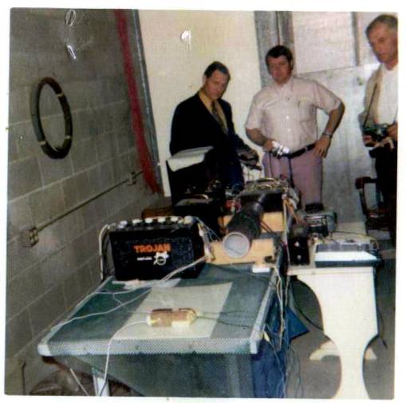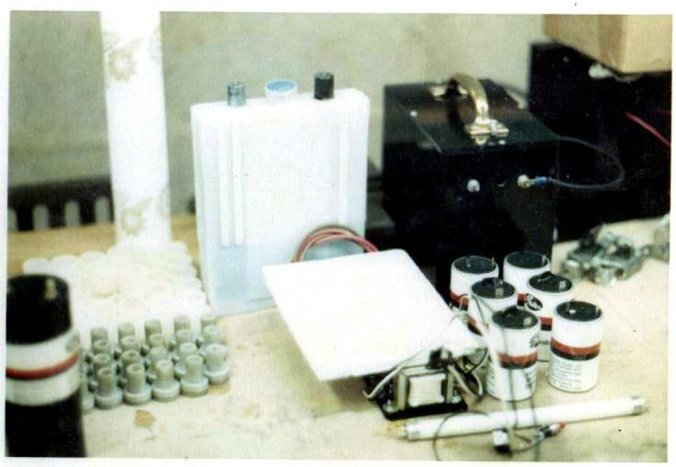

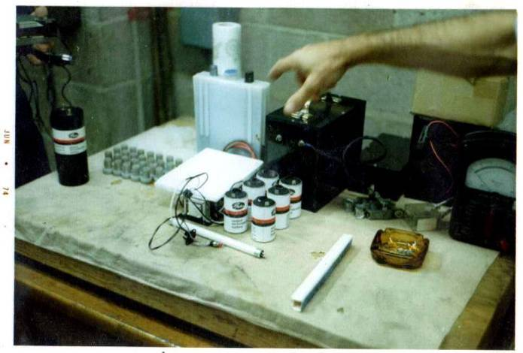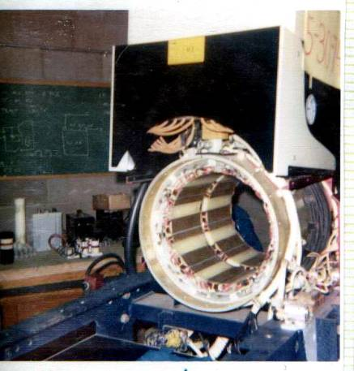

1st, I would indeed enjoy viewing more photos, whatever you may have . . . please? And no I did not receive any other pictures. In your circle of friends/investors, you might inquire to see if any of them know of me. Also, I'd invite others to correspond with me in hopes of gaining more insight to an area where I was kept in the dark. Some day I intend to put together a autobiography of my father, his 1st and 2nd family, his invention the days leading up to his death and beyond. But only if I can gather enough missing information between the years of parents divorce and his untimely death. A second issue is also in the making surrounding the discrepancies and circumstances of his death and on up to current.

I shall send you what I have.

Be sure to check out Dr. Lindeman’s web site. He has the best collection of archival EV Gray ligature on the web. I don’t have the site address on this computer, but if you don’t have it I can get it for you from my work computer.

2nd, Regarding the "EV-1 Saturn" by GM, I've got it around here somewhere and soon as I can locate this fellow, I'll send the info to you . . . pictures too.

Thank you for the consideration.

3rd, Electrical and electronic design works have always intrigued and fascinated me throughout my life, but I have very basic knowledge to work with. Your work peaks my curiosity, I'd like to read-up and learn more . . . so I'll try! The "attached" paper is a hand full for me at the moment, but I believe I understand it to a point! I marvel at folks like you, and how these ideas click in your minds! I used to be this way with mechanical applications, but I've been away from those forms and processes for an awful long time. There have been many a time when I wished to be back in the design field!

I’m sure the work you do now is just as important in the overall scheme of things.

4th, How well do you know Carl Lennon of Florida?

I just made his acquaintance this month when I contacted him about his article in “Electric Spacecraft Journal”. We have talked on the phone twice and shared about 6 e-mails. I understand that he has already talked to you. I hope he was able to contribute some information to your quest.

It seems as though this is the area of most interest, the assembly least understood.

Actually none of these systems are well understood. It is believed that there are two processes involved. One system was used in the “Black Box” demonstration devices. This system was alleged to have had a COP (Coefficient of Performance) of about 4.0. Meanwhile, the motors are believed to have COP’s in the area of 100 and are prime evidence of a second more powerful process. It is not known if these two processes were independent of each other or if one was the second stage for the other. It is generally believed that the CSET device is the advanced power stage process. It is unclear if it can operate by itself or if it needs the non-classical output of a “Black Box” device in order to function.

I’m in the camp that believes the CSET needs a non-classical input before it will demonstrate a large non-classical output. I consider this a shrewd maneuver on your father’s part to protect his invention without disclosing its complete operation.

Carl Lennon is looking for a non-classical output with a classical energy input. He might find it. Some people have reported anomalous observations with this kind of equipment, but the experiments are not repeatable and have not been well disclosed to follow up on. My limited experimentation with one form of a CSET was not encouraging so I’m looking elsewhere for the “Mother Load”. But I could be wrong also.

Am I correct? Is this the assembly attached to the front-end of the motor?

The device attached to the front end of the EMA4-E1, according to the patent documents, is a huge rotary switch mechanism composed of several pairs of spark gaps employed as switches to direct energy to the various motor electromagnets in the proper timing sequence. It is also responsible for speed control. It’s the box on top the machine that has the “Magic”, in my opinion.

It is unknown if the EMA4-E1 motor actually used CSET’s or not, this is an ongoing debate. I tend to doubt it because of the lack of space. But the jury is still out on this one.

The EMA6 version motor defiantly used CSET’s and they are the 4” diameter copper cylinders mounted under the motor. There are three of them in a row housed in a clear plastic box.

What exactly was the function of the "Converter Switching Element Tube"? Did this mechanism convert D/C to A/C current, or what" I've been thinking about this portion, it seems to be bouncing around in my head. Tell me more of it's function. Who knows, maybe the answer is locked-up inside me too! Odder things have happened in the name of science!

It is generally believed that the CSET is a non-classical power amplifier that received high voltage low energy DC pulses (or some other form of non-classical pulsating energy) then increased the energy content of these pulses by about 20 to 100 with no further energy input to the system. These DC pulses were then collected to do some useful work with these huge anomalous energy gains.

Consider, my father had an 8th grade education, yet, he was a fabulous designer/fabricator, especially with mechanical applications! I remember when he started getting these ideas for this motor (we lived in Las Vegas, Nevada), my brother Eddie and I would watch him put pieces of odds-n-ends together, and bit-by-bit it would start to look like something we'd never seen before! Oh sure, he'd tell what he was trying to accomplish . . . but all his verbal impartations (explanations) were purely foreign language to us at the time!

Can you recall the year in which these experiments took place? Or when they started? An attempt at reverse engineering depends upon knowing what components were available to individuals and at what times. It has been reported that your father started this technology in 1957 and got his first motor to run in 1961. That’s a long time to work on a project with out any examples and no positive feedback. What your father lacked in formal education (which might have been a hindrance in this area anyway) he certainly made up for in pure gumption. Was there some event that inspired him to hook up wires, coils and batteries? Where was he working at during this time and what did he do? Did it appear that this project might have consumed a significant amount of time and family resources, or did it have equal footing with other family pursuits? Do you recall when the first “investor” became involved? Answers to these kinds of questions help settle issues about what the circuit could have been composed of, but even more so it helps determine what it was not composed of.

Some times his experiments were a dud, some times they'd catch fire, and some times explode . . . and we'd all run like the dickens to find cover!! Whew! rather these experiments worked at first or not . . . he'd simply clean-up and start over as soon as he could find some free time!

Do you have any idea what was his inspiration was? How does a man focus so much limited free time working on something that has never been seen with out an idea as to how or where he is going. Were all these garage experiments done independently or did he have friends that helped out? Did he spend any amount of time reading books that might have been related to this subject or did this work all appear to be all “hands-on”?

Actually, Dad would disconnect any electrical supply (if there was any involved), then my brother and I were given the (as my father called it: OPPORTUNITY) to clean-up his mess!

What was the “mess” composed of? Were there glass shards in the material to be cleaned up”? Were there liquids involved. Melted copper wire? Wooden fragments? Was the Fire Department ever involved? Did your father even need to go to the emergency room? Did he ever receive a burn that you know of? Did you ever see him wear safety equipment? How much smoke was produced? Like, as much from burnt popcorn in a microwave oven? Did he salvage the remaining usable components before the clean-up operation began?....... I could get carried away with line of thought so please pardon my multiple questions. Each one could add a fragment or two to our information base.

Actually, we had a lot of fun! Anyway, before I wax to far the off-track, the realm of science that you and Carl Lennon occupy are is a space and dimension that I dream of! I hope to learn more from you . . .

I shall certainly pass on what I know. I’m pretty sure Carl will do the same. I shall also include names of other people who have done work in this area.

5th, As I recall, Peter Lindemann was on the inner-circle with my father from the early 70's, and on . . . till my father's death! I believe my brother Eddie had some communications with him even afterwards. I remember meeting him on a few occasions at the shop/lab, on Calvert Street in Van Nuys, California, and seeing him a few other times . . . such as the "Premier" in Studio City, CA (1-91976). I'm surprised he doesn't know more about the "EMA" apparatus and it's various parts and assemblies!

This is strange; Peter has always presented his involvement as being on the outside looking in. I have no idea what the real story is. He dose claim to have received a lot of useful information from the husband of the youngest daughter of the second family, April I think her name is.

I would have thought him to be in possession of one the complete machines!

The only known hardware (that I know of) is owned by Al Francoeur of Penticton, BC Canada [AL.F@telus.net] who bought the EMA4 and EMA5 prototypes from Norm Wooten for $5,000 about two years ago. Al is an unemployed electrician who is on disability (he might be off by now) who has a fascination for motor like inventions. He has three designs of his own. He took a loan out to make this purchase and has shared a lot of information about the construction details of these machines on the internet. I have visited Al a few times and consider him to be an honest and sincere working man with a dream and a lot of gumption. I would say he is in his early forties. I certainly wish him the best in his adventure. He is hoping to secure funding to get these motors operating. I don’t think this has happened yet.

Well, anyway, what's he working on these days, especially regarding varying applications of my father's invention(s)? next time you see him, ask him if he remembers me (the 2nd son with Rheumatoid Arthritis), and inform him that I'd love to hear from him, and, be updated works! Sincerely.

Peter is working for John Bedini on the Bedini monopole technology in Post Falls. I don’t think he has done anything in the EV Gray Technology since he converted his book to DVD format a year ago. I shall forward him your addresses.

6th, The fellow which Peter is working with, John Bedini, I'm not familiar with him, nor their joint venture into physics. Just what are these two attempting to uncover/discover?

John Bedini was involved with Ron Cole in California. Apparently your father would visit John’s shop in Slymore California when he was looking for Ron Cole. In 1992 John disclosed some diagrams that he recalled during his visits to your father’s shop. I call these drawings the “Bedini field Notes” and they show the over all equipment layout of the EMA6 wiring, but do not disclose the internal operation of the power supply.

John has been granted three of his own patents for different devices that allegedly when taken together are the foundation of a “Free Energy” type of machine. John and Peter have received investor money to further develop this technology. It is my understanding that they are making progress in a direction different than your father’s approach, but at least it is still a non-classical process that they are working on. If they crack this nut maybe a new physics will develop that will shed some light on this part of the universe.

You know, I'll never understand why so many folks who tinker in the sciences are so slow to write down in detail every step of their theories and/or experimentations! Perhaps it's fear of failure, fear of success, or, perhaps it's simple scientific dysfunctionalism!

Well engineers are poor technical writers in general and “hands-on” experimenters are even worse. No one gets paid for taking the hours to write up a failed experiments, and who wants to admit to them anyway? If the experimenters in question are “Gold Digging” then you are not going to hear from them anyway. This field of non-funded research is not like a college where professors either “publish or perish”. Non-funded researchers are short of both time and money, if they have time why attempt to write up a failed experiment when they could be working on the “real” solution. There is little reward for documenting this kind of research. In fact if you want to receive a few negative e-mails just post a lengthy paper on the internet on some non-classical subject.

Now the people who are good at theories, like Tom Bearden, love to write and you can find their writings in a multitude of books and web sites. I got tired of collecting, reading and processing this kind of material. If there isn’t a hardware connection then I’m not interested. There seems to be a large number of people who love to draw theories in the sand and then argue about them.

Well, there is one other, and that has to do libido (ego)! It gives to those around them a air of mystique! Thus, folks like this, folks like my father . . . thrive on the attention, and the so much ado over them (personally)! Unfortunately, if theyhave anything actually on-the-ball, critical elements, procedures, formulas, etc. are lost . . . perhaps forever!

Looks like you have them already figured out.

Say, what is the theory of Tom Bearden all about?

He has many. He just published a 900 page book that covers most of them. [craddock@west.net] Interesting reading if he could only provide the base experiments to prove his many assertions. There are several other authors. I have a collection of about 30 such books. I suppose some of them have some truth in there somewhere, but if it can’t be measured or observed then it can’t be engineered. Tom is into the idea of “negative-energy” and “holes” and how they allegedly work. Fine, where’s the Beef?

7th, I've never been a fan of "chat-rooms."

8th, Mark, I am very interested in reading you findings regarding "Boot" Mallory and the Mallory Electric Company of Carson City, Nevada.

Already sent.

It would also be my extreme pleasure to review your literary work concerning the historical accuracy of this passage of time.

More to come as soon as I spiff them up a little.

In a final thought (for now), I just called the man who updates and maintenances my p/c system, he says that my e-mail program should receive a 13MB file, however, should you choose to try sending your "works" in this manner, he suggests that you also send it to his e-mail address too: mcmercer@gmail.com for safety's sake. He will in-turn burn it onto a CD for my use and files. On the other hand, you may select to "post" a CD to my "snail-mail" address as listed:

Dr. James A. Gray, Sr.
1335 North Caddy Lane
Wichita, Kansas 67212

9th, Mark, should you ever desire to chat via the telephone, my telephone number is: 316-641-7029 . . . personally, I would be delighted to make a new friend. As well, we both have two common interests . . . my father and, the "EMA" motor!

I look forward to share what I have and hope this information is saved for others.

Sincerely, James A. Gray, Sr.

From: Mckay, Mark
Sent: Friday, August 04, 2006 11:03 AM
To: 'Dr. James A. Gray, Sr.'
Subject: Interview with surviving EV Gray Observer

Dear Dr. Gray,

We have found one still living gentlemen (79) who observed first hand some of your father's work in 1973. His technical comments are very helpful to this research effort. I thought you might like a copy of his comments.

Otherwise, research is progressing slowly as we attempt to re-discover these lost secrets.

Mark McKay, PE

From: Dr. James A. Gray, Sr. [mailto:icyams@sbcglobal.net]
Sent: Friday, August 04, 2006 9:56 PM
To: Mckay, Mark
Subject: Re: Interview with surviving EV Gray Observer
F A B U L O U S & F A C I N A T I N G !

Mark,

It is good to hear from you. Indeed, I am prepared to spend more time and energy to help this project succeed!

Feed me whatever you find viable and encouraging! I yield to, and rely upon your expertise
in these matters! Sincerely, tell me if there is something to do and/or person(s) I could talk
too for the effort!

I have read the attached six page dialogued transcript and boy did it fire-up some recall. Basically, I've shared much of this information already. Much of what he has said validates what I had recall of with exception of his electrical details. However, when it came to his physical measurements, most were off, I'm positive. Well, there is much of what he has stated to discuss. I need to describe the discrepancies., as well as the similarities of his recollections. Mr. Cannady was pretty accurate as I pictured his descriptions in my mind! I'd like to meet him. I don't recall him personally, but then, their were many folks I didn't have the good fortune to meet.

Again, I only wish I could have been more privileged to observe more. However, at the onset only my youngest brother had that distinction but he was to young (literally a boy) to understand the complexities of Dad's work. However, towards the final days, both my elder brother (Edwin Jr) and youngest brother (Mark)were with our father quite a bit. Especially Jr., he carried money belts and ran trips for the business. Mark traveled with Dad quite often. Still my father didn't trust me because of my knowledge as a mechanical engineer . . . But like Dowd Cannady, "I know for a fact . . . everyone of his projects were bonafide authentic, working, one-of-a-kind pieces of factual enterprise!"

Mark, I'll get back to you as soon as I am able, which won't be long. My interest is deeply stirred

I sincerely want to help in whatever way I may . . . Dr. James Gray.

PS: Mark, if it would be more advantageous, call . . .

==================================================================
Dr. James A. Gray, Sr.
"Prayerful Solutions!"
Christian Counseling Services

From: Mckay, Mark
To: Dr. James A. Gray, Sr.
Sent: Tuesday, August 08, 2006 7:54 PM
Subject: RE: Interview with surviving EV Gray Observer

Dear Dr. Gray,

Attached is a short Novel that attempts to cover the Saga and Adventure of your father's technology. 70% of it is speculation on my part. It only demonstrates how much I don't know. I understand that your father was raised in Washington State, went into the military at a young age, worked in Florida, moved to Carson City, then to California, and then lived several places after that. I certainly don't know any of these dates or who he worked for, or what he did for a day job, much less when he went to work for himself full time.

The story attempts to explain one possible set of circumstances as to why this breakthrough never made it to market.

If you have the opportunity I certainly would like your feedback on this attempted mini biography such that I can reduce its speculation content. I don't believe there is any other document available that includes as many collected "facts" as this paper presents. I hope that I can make it better with time.

So far I haven't had the time to include the information gained from the Mr. Cannady's interview. I've been to busy working on actual circuits in order to explore the technical possibilities that were suggested in the interview.

Please pardon all the errors you are going to find in this paper.

Mark McKay

From: Dr. James A. Gray, Sr. [mailto:icyams@sbcglobal.net]
Sent: Tuesday, August 08, 2006 10:59 PM
To: Mckay, Mark
Subject: Re: Interview with surviving EV Gray Observer
Dear Brother Mark,

Sorry to say that, only one item is factual in your "opening" paragraph . . . my father did indeed enter the military at an early age. But only for a very brief time. If you can hold on for the space of one week, I'll respond to these remarks with valid information.

I've taken this week off to help two of my daughters with their children. They're both teachers here in the Wichita Kansas school system, and their children don't start school till next week. Yet, all teachers began this week. But after this weekend, I'll have time to help you out. In fact, I still owe Sterling Allen a rewrite on a piece he sent me many months ago! I hope he'll forgive me!

Again, the first of next week I'll sit down and read your "novel", then write all correction to my honest knowledge. Maybe even before then . . . I'll give it the ol' college try!

Sincerely, Dr. James A. Gray, Sr.

Thu 8/10/2006 4:40 PM

Dear Dr. Gray,

I kind of thought I didn't have my "facts" straight. Is the biographical information on Mr. Allen's site a better rendition? Again, that document is short of dates.

Don't worry about a prompt response as we are all short of time. I will be glad to receive any historical information you wish to share in your own good time. I find your father's adventure worthy of a Novel in its own right in addition to its scientific importance. He reminds me so much of my own adventurous and uneducated father.

Attached is a short technical article about one of your father's recovered experimental motors. I call it the "Start Motor". Just one of the pieces of the whole puzzle.

I'm finding more information about the Crosby connection. That is "Bing Crosby" as in the famous singer and actor. Apparently Crosby Research was his project and he supported a lot of creative inventors, especially in the sound recording field. He has his work done at Cal Tech. Anyway, when I get the time I shall explore the archives at Gonzaga University, here in Spokane. Bing Crosby went to college here and he built the Crosby Library. So they maintain the national archives of his life's work. I wonder if there is any record of his involvement with your father. Bing died in 1977, and that seems to have been the end of the financial investment for that decade. Boot Mallory died the next year. As far as I know these two sources made up the lions share of the investment capital from 1971 to 1977.

From: Dr. James A. Gray, Sr. [mailto:icyams@sbcglobal.net]
Sent: Saturday, August 12, 2006 3:57 PM
To: Mckay, Mark
Subject: Re: Interview with surviving EV Gray Observer
Dear Brother Mark,

I hope you're sitting down because I need to share some very unflattering words with you regarding your knowledge of my father!

But first, please share with me where you have obtained the biographical info of my father/family journey in life! If, in fact, you are relying on information from the siblings of Dad's 2nd family (Patrick and April) . . . you are being terribly mislead. I do not hold them totally responsible because they were so grievously
"lied" too! My/our father is a man who was in every sense of the word, a street savvy "shuck and jiver!"

I'm sure you're going to be genuinely disenchanted, but I've read into the third page so far . . . and, I am going to reconstruct with proper validation, your writings!

But I hope you'll continue to publish the truth, regardless. I am beginning to understand why my father wouldn't allow me to be privy to the "inside circle." He didn't trust me to keep quiet. I never was much of a confidant' in holding to any of his stories!

Tis a shame that he had such a marvelous mind for science, yet, couldn't help spinning outrageous yarns to promote his enterprises. Again, whatever I change/challenge, I will do so with valid, certifiable information.

Mark, may I have your telephone number . . . Please?

Sincerely, Dr. James A. Gray, Sr.

Mon 8/14/2006 9:29 AM

Dear Dr. Gray,

My knowledge of the truth of your father's real adventure is almost non-existent. All I have been able to collect is bits and pieces of superficial mythology from several unsubstantiated sources. There does not exist a document (that I know of) which contains a complete outline of the successes, disappointments, and challenges that your father faced in his quest for providing the world with an age changing revolution. The real question, that baffles many of us, is how could this demonstrated powerful technology not make it to market, even after 27 years of effort. Everyone has their thoughts I wrote down mine.

It has been my experience, in engineering, that people have a hard time describing what they want in the construction of a building or project. But, place a drawing in front of them and all kinds of ideas, changes, modifications, and re-works come forth. So this was the intent was with this effort. I figured that if I started with a complete story of some sort, even if it contains many gross errors, it might elicited the necessary corrections from the people who were there and in the know. It's difficult because so few people are left that know anything. Unfortunately, what I don't know I had to make up to bridge the gaps between the relatively few known events.

Again forgive me for taking such liberty in a history that is near and dear to your heart. I know this story is misleading and I will not release it until it has your blessing.

All the information about Patrick and April come from the postings on Sterling Allen site, I know of no other source. I may have well made gross errors in extracting my information from these letters. Again please excuse me. The reference to April is that she had in her possession, or knew of someone who did, a large number of drawings. I made the projection that these drawings (with out actually knowing) were most likely the hundreds of shop drawings that would have been needed to have the components for the motors fabricated in the local machine shops. These same letters also comment on a negotiable sum of money that would be accepted before these drawings would be released. I think this is about all I mentioned about April and Patrick. I considered this information to be important because it points to some remaining and unrevealed material.

I project (again with out actually knowing) that the true "Kernel" of your father's technology will not be found in these hundred of drawings. I could be wrong and if so then the world would be much better off if a complete description of the electrical converter were to be found among those describe drawings.

From what I know of your father's technology, he had every right to spin outrageous yarns about his accomplishments. The documented 1:270 energy gains from "nothing" is an accomplishment equal to or greater than the development of the printing press.

Feel free to reconstruct my writings from the ground up. They were only meant to be something to shoot at in the first place. I would so very much like to have the true accounting of the real events.

My phone numbers:

Direct line at work 8:00 to 5:00 Pacific time, one hour for lunch, is 509-842-1210

At home it is 509-489-2044, but I'm not there much of the time

Again Thanks for the Consideration in taking the time to review this "Novel" and correct its many errors.

Sincerely, Mark McKay, PE

From: Dr. James A. Gray, Sr. [mailto:icyams@sbcglobal.net]
Sent: Monday, August 14, 2006 3:27 PM
To: Mckay, Mark
Subject: Re: Interview with surviving EV Gray Observer
Dear Mark,

I am going to be very thorough with you in defining my father's genesis to the onset years of Dad's inventions. As I have said before, I only did but a few mechanical drawings of the casing, bars, stators, etc., in the beginning. Thus, other than personal history, which I perceive as paramount to assembling a valid picture/ understanding of who my father really was, and why he was so compelled to eloquently create/generate a new view of himself. Tis not all that difficult to understand, my father was in actuality . . . very insecure as an individual. On the other hand, much of his dialogue and rhetoric to his investors and media regarding his contacts and past were . . . false!

Oddly enough, regardless of all of his "B/S" and lack of formal education, he was smart, clever, witty and quite obviously, he indeed was brilliant creative in creating devices of humanitarian need! In essence, he was in all rights a "visionary" of great technical accomplishments! Mark, if at any time you have questions as we embark upon this journey for truth, please jot them down and send them to me, or call to further discuss your thoughts.

Personally, I believe the more you know of my father, the greater will be your publication. It is always more advantageous to give your readers the "full scoop" about your subject, as the person inside the inventor! More books are published about the personhood of great men/women in time, than their actual accomplished! Trust me on this, I have read a tidy some of books over the years . . . about the"person", tis much more interesting to know what made them "tick"! Well, my father was very diversified as an individual, but you'll have to take the "good with the bad" to gain a total perspective on Edwin Vincent Gray! I venture to say that when completed, you'll have a best seller in both fields of science and human drama! I encourage you talk with publishing houses, discover what can really make your book's subject, Dad, Mr. Edwin Vincent Gray the man and his invention intriguing to your readers! Indeed, you and I may generate some controversy, but it will all be true and make for grrrreat reading! My father was a very colorful man, he was a many faceted person! He was indeed more than a lab-coat!

Give me your thoughts please.

Sincerely submitted for your perusal and edification,

Dr. James A. Gray, Sr.
"Prayerful Solutions!"
Christian Counseling Services
1335 North Caddy Lane
Wichita, Kansas 67212
(316) 641-7029

Mon 8/14/2006 3:38 PM

Dear Dr. Gray,

Thank you so very much for the call.

Pardon me for not being in my office this morning when you called. I had a rare request for a short field study at our local Wastewater Treatment plant for some additions to their new Fire Alarm System. Normally this is the salesman's job but he was very busy with a quote for another project. So I was able to get out of the office and get a free lunch to boot.

I probably won't be home this evening till after 8:00pm Pacific Time. I have to box up auction lots of laboratory glassware that my son and I sold on eBay to get money for him to study in Hong Kong this Fall. I shall attempt to call you in a moment.

I am most happy that you are willing to set the collective records straight on your father's Saga. I agree with your assessment on the important reasons why your father's story needs to be recorded and made available to others who might choose to follow this path. Not to mention that something like this could have really happened outside of Science fiction.

The story line is unique. A real live person in our times had rediscovered/improved or made workable a solution to cheap energy for everyone forever, and he knew it. Outside of the scientific advancement the understanding of how this one man decided to proceed with this kind of knowledge is a good story no matter how it turned out. All of our human desires and vices come to the front when given such a gift-liability. It also reflects deep chasm of the world we live in and the subtle boundaries of power that few people rarely encounter.

I really think there is enough technical meat already available to give the average reader more than enough engineering details to explore. The emotional and personal side of the story is just as important if not more so. Your father's particular personality needs and/or action choices are to be found in all of us as well as those individuals fortunate enough to take mankind to a higher level.

I'm not a gifted writer, in fact I'm really slow at it. But, because of the importance of this subject I shall do what I can and document every usable detail you wish to share.

I would be glad to explore a book publication option. So far the "Novel" is only 30 pages long. With photos and illustrations it might make 45 pages. I suppose a publisher would like to see at least 200 pages. At least that is the size book that is sold by AUP (Adventures Unlimited Press) a publisher that deals with this kind of material. I have no knowledge of what a main line publisher would want like Doubleday or McGraw Hill. But, I suppose that kind of information is on line. Different publishers might want different things. One might want the technical material reduced while another might want the personal story reduced. I have no way of knowing what the market would like.

There might be a demand for about 200 copies of the technical material from individuals in the Free Energy Community. However, they are not above scanning in a book and giving it away free off the internet. It seems that this has become a practice this past year. The better the book the sooner it will be pirated by the very same people it was intended to inform. So, there is not much money to be gained in selling to this group.

I have no Idea if this story would have enough wide spread appeal (at least by a company reviewer) to be selected for commercial publication. It should, but real writers out there are very good at what they do and fast. It takes me 4-8 hrs to compose one page. I hear a good writer can whip out a page about as fast as taking dictation. But we can run it up the flag pole and see what happens. At least it can be published on Sterling Allen's Energy site and it will stay there for years, or be copied to other sites. At least the information will be available.

These are just some thoughts,

Mark McKay

From: Dr. James A. Gray, Sr. [mailto:icyams@sbcglobal.net]
Sent: Tuesday, August 15, 2006 12:39 PM
To: Mckay, Mark
Subject: Interview with surviving EV Gray Observer
Dear Mark,

I strongly suggest not advancing this information to the internet media until we are finished,
whatever and wherever that may lead.

I agree, that was always my intention.

I also suggest not reviewing/discussing it with anyone in the "Free Energy Circuit" until completion.

I understand, I only have connections with three other active researchers where we have been working on various circuits and electrical experiments. Those people are Dr. Lindemann, Ben Thomas, and Carl Lennon. I have donated two technical articles to Sterling Allen (the second one "The Start Motor" has not been posted yet) and one to Steve Eastlick (Tesla Tech Magazine - "The Mallory Connection). Other than that I'm an unknown among other Free Energy researchers. I receive the postings from the EVGRAY discussion group on Yahoo.com, but have never posted any messages. I have never been to a Free Energy Conference, but buy some reports and videos from selected lectures.

I attempted once before to share a lil' insight into my father's character, but I was scorned as such. Ironically, this individual was cranky over my father's handling of himself/business/inventions, etc! Yet, in my business, you can't possibly know who/what the individual is about . . . until you have "all the information"! You cannot find closure until all is known of a given subject/topic.

I have seen that sort of e-mail back stabbing in these discussion groups. I seriously believe there are about three professional paid rabble rousers that are tasked to disrupt any fruitful discussion of your fathers work. Their job is to throw stones at anyone who even gets close to doing serious circuit development and possibly want to keep tabs on anyone who is really making any progress. Apparently their efforts have been successful. I haven't seen any meaningful exploration of the obvious technical threads that were left behind to follow up on. Instead they chase various other forms of rotary motors, some of which may have merit, but the intent seems to steer away from the central power converter design.

And yes, any publication can be safe-guarded through simple process of "copywriting"
before sending it to a publishing house. You can bet your readers are going to want to read
the finished work! I've spent the last 30+ years writing essays, booklets, etc. And just
like music, none of it shows up on the net with the new protection laws . . . without the
author and/or publishers explicit certified consent!

That is not the case with Dr. Lindemann's Book "The Free Energy Secrets of Cold Electricity". He says that his sales have dropped to almost nothing since his book was copied to the internet. I know people are able to steal music and movies on the internet all the time. A book is no different. I'm not sure how this is done, but it certainly is, with or without copyright.

Just remember this, my father is the number one name on the worldwide net regarding
the business of "Free Energy" . . .

No doubt,

of course this kind of information will be in demand.

As well it should be,

Don't sell your/our story short until you, yourself have a fuller insight of your subject . . .
my father!

Well, the illustrated 6 page article on the Mallory Connection didn't generate one single comment, question or complaint. It was like it never happened. I thought someone would tell me I was right on or full of BS or request more details. I had my company e-mail right in the title block. I was hoping to attract one or two like minded experimenters. It didn't happen. Maybe that particular magazine has such a small readership. Actually, there are so many specialized areas of exploration in this Free Energy Field that it is rare to find someone who is working on the same material, much less in the same way. I know that anything outside my little area of interest is like reading a foreign language, and I have a strong historical background in these other technologies. So it is no wonder that I received no responses, but it was still worth the effort.

It seems that many are interested in your father's technology (if someone else gives them the key) for reading, but few are actually attempting to rediscover it with HV bench top work.

Tell you what I'll do, for starters, I'll piece together my father/family's timeline with experiences,
since the mid fifties, indicating moves and businesses enterprises in an effort for you to
determine the truth of EVG personally and professionally.

That would be a huge help. That would sort out a lot of technical questions as well. What he did at different times helps establish what components he might have had to work with and what kind of expertise he might have acquired. A big question is when he changed from vibrators to transistors (if he actually did) for his front end power supply. I suspect that the availability of cheap HV Silicon controlled Rectifiers was an important step in your father's advanced designs.

Yes, his inventions did exist and work,I saw them!

I have no doubt, base upon the the available evidence.

But to understand his motivation as to why he left the mess that he has for others
to hope and try to sort out regarding his motor, well, it can't be done until you know how he
ticked inside.

The 64 billion dollar mystery question(s)

Sincerely, your friend in honesty,

Did Andre' Popoff ever exist that you know of? This man is the only link between your father and Dr. Tesla. If there is no Popoff then there is a chance that your fathers work is independent of Dr. Tesla's investigations and completely original? Perhaps your father needed to introduce a casual connection between Dr. Tesla and himself to give his work some technical creditability in his early presentations, just like he said he worked for NASA. Could this have been a needed promotion fabrication? If so, then it really sold well.

Dr. James A. Gray, Sr.

PS: I only wish I had the finances to get together with you for a one-on-one chat up-close-and-personal . . . maybe some day. In a final thought, if by chance any of your journeys bring you and/or your wife this way, please come, and stay with us a few days. It'll be good fellowship, and, it'll give you and I a
wonderful opportunity to discuss in-depth my father and his life's works and ambitions.

I shall certainly keep your generous invitation in mind.

Attached is an unpublished technical article about the EMA4 and EMA5 motors you might find interesting. I certainly learned a lot from my short exposure to this equipment.

By the way did you get the chance to read the "Mallory Connection" article? It is probably full of errors as well and needs serious correction. Let me know and I'll send you another copy if you don't have it on hand. As far as a writing effort goes I thought it was one of my better attempts.

Mark

From: Dr. James A. Gray, Sr. [mailto:icyams@sbcglobal.net]
Sent: Tuesday, August 15, 2006 12:39 PM
To: Mckay, Mark
Subject: Interview with surviving EV Gray Observer
Mark,

I don't know why, but between you and I, there's something about Lindemann and Wooten
that makes me ill at ease because they were both in and around my father's work during the
early, mid 70's! Somehow it seems as though they had/have opportunity and ability to know
more than they let on! Sadly enough, my father estranged his first family until the late 70's.
That's when my youngest brother (Mark) and eldest brother (Ed) became involved till his untimely
demise on April 21, 1990 . . . according to the official "Death Certificate" so registered by the
Department of Vital Records in Carson, Nevada. Ed Jr. and Mark kept Dad's cloak of secrecy to
the family, and others Dad deemed untrustworthy and/or shunned for whatever his reasons were
at the moment.

Anyway, have you had any dialogue with either of these men? If so, what are your impressions
of each?

From: Mckay, Mark
To: Dr. James A. Gray, Sr.
Sent: Friday, August 25, 2006 5:39 PM
Subject: More EV Gray Historical Photos

Dear James:

I certainly enjoyed our enlightening conversation last Monday. That evening I came home to a flooded basement with a ruptured hot water tank. I have never seen one fail like that. I took Tuesday off to make repairs and to do some cleanup. Things are under control now.

In thinking about what you have told me, a few questions come to mind that you might consider in good time.

1) I'm a little lost on just where you ended up in Nevada when your father gave up the homemade motor home to pay off the gambling debt. Was it Las Vegas proper or Carson City? The two are about 50 miles apart, or so it appears on the map.

2) While working in the Body Fender Shop in Nevada, did you recall ever working on any professional race cars?

3) Do you have any recollection of any associations with the Mallory Company of Carson City? Having done any work for them or their employees?

4) That explosive experiment that your father did between the two buildings, was that in Nevada or Van Nuys? Can you put a date to that very important event?

Perhaps these issues are covered in your time line already. These are important technical events because I'm attempting to understand how your father came to work in this arena.

Other circumstantial questions:

1) Was you father ever a "Ham" Radio operator or hold any sort of amateur FCC license?

2) Did he every do around the house electrical repairs when needed"

3) Did he own any electrical test instruments such as a volt meter, amp probe, tube tester, or similar advanced tool?

4) Did he have any collections of books at any time that you recall. If so, do you happen to know what the subject matter covered?

Don't bother writing these thing down. When we talk next time I shall bring them up. I just wanted you to ponder them for a brief moment because I think they are important and might point in further directions to explore.

I contacted the Gonzaga University Library to inquire about the Bing Crosby Archives. I described what I was looking for to the assistant research director. She said she would look into it and call back next week.

My son, Jonathan, sent me this link to a company in Ireland who claims to have built an Over Unity Generator. Their site contains nothing about the technology involved, so I don't know if it has anything to do with a follow up on your father's work. Usually, I run across one or two such claims a year. They usually fade away with out a trace after 6-12 months. They are at:

http://www.steorn.net/

Free Energy claims seem to pop up all the time. I suppose one of these days some one will get lucky.

I have looked at this site twice. About all I can extract from it is that they have built some king of Over Unity Generator, but no details beyond that. A lot of discussion on their forum, but no technical substance that I ran across. It is much like the dribble that I see on the Yahoo.com Free Energy chat rooms. They may be onto something, if so, so much the better. The the real crux of the issue is what is the effective Coefficient of Performance? (COP) of their new technology? If it is, say 1.25, then yes they can claim a novel technical breakthrough and perhaps it might be reviewed by academics and something might become of it. But, in order for this technology to solve the energy crisis it would have to have energy gains near what your father got or in the region of COP's of 250 or more. Then we can talk about telling the Oil barons to keep their black goo. But for now this might be a step in the right direction.

Like I said, I see claims like this about once or twice a year. The last one was the GMAC machine. Nothing seems to happen to them, they just fade away. I hope this small company has considered the realities of their announcement and the potential negative impact it might have on their operations if they are perceived as even a small threat to established big business. The violation of the energy conservation laws is not what the real people in power want to become mainstream. If some small company, like this one, claims to have done it then others may follow with different variations and something might be found that certain people would like to remain hidden for a few more centuries.

I can't find anything on their web page that describes what their approach is, other than it is a "generator". I have real doubts about an announcement that has so little technical substance to it. Maybe they do have something, but they are not disclosing it. The "Challenge" they are advertising seems like a waste of time. Put a price on the devices and start selling them, don't play useless intellectual games attempting to prove over unity. Let the performance of the "Generator" speak for itself, make some money, and let the unemployed physicists of the world figure out a new scientific models to explain (and then argue about) how it works.

With Deepest Regards,

Mark (Attached Photos Below)

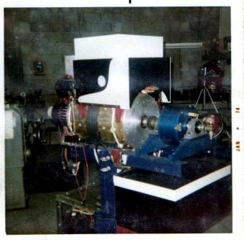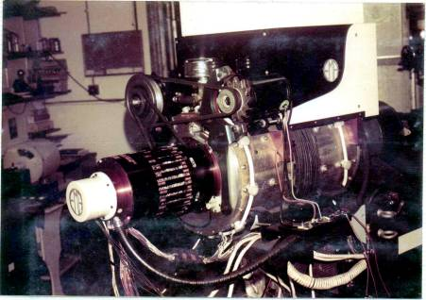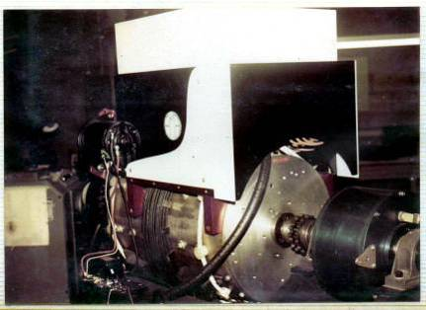

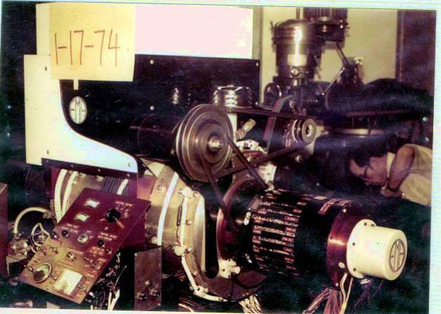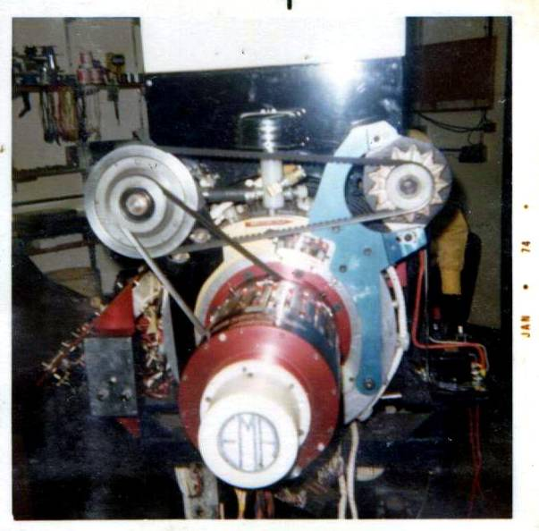
Dr. James A. Gray, Sr. [icyams@sbcglobal.net]
Fri 8/25/2006 5:32 PM

Dear Mark,

I have just completed my "timeline." I'll proof read it tonight or tomorrow morning, then
I'll shoot it to you as an attachment to an e-mail.

Just remember, the purpose of a "timeline" in our situation is to weave the truth into
existence where many fabrications on the net has painted a picture of my father which
is in absolute error! In so doing, I've interjected considerable family events to show that
my father was incapable of being in certain places, and doing so the things accredited
to him. Before Renata and Dorothy McKellips came along, dad was a very capable
businessman in the end . . . but most importantly, he was a "family man"!

PS: I will answer the questions listed below sometime next week . . . not before.
Also, I'll set the record on some very critical stats regarding my father's birth,
demise circumstances, and death (where it happened, how, etc). Again, after
next week. Incidentally, all the answers to these elements will be gleaned from
three necessary documents:
1- Birth Certificate,
2- Police Report,
3- Coroners Report
I'd send you a copy of each but it is clearly stamped on each item "Unlawful To Duplicate."
I'll also send pertinent data for your procurement of these documents, should you desire to.

****You know, I hope the truth will be as captivating as the "yarns"!

Starting tomorrow morning, I will be deeply involved in prayer and study for the rest of
this week for a "Labor Day" special service!

Thanks for the additional pictures too!

Sincerely, James . . .

From: Dr. James A. Gray, Sr. [mailto:icyams@sbcglobal.net]
Sent: Monday, August 28, 2006 4:36 PM
To: Mckay, Mark
Subject: Edwin Vincent GrayTimeLine.doc
Dear Mark,

"Attached" is a thumbnail (but very accurate) sketch of my father/family history!

As you will see, and can verify, there was NO possible way for him to have been
to, and/or worked for NASA . . . Nor did he ever meet Dr. Popov and/or anyone
else which he has claimed prior to late 1969 (very late) or early 1970!

No family member can "refute" what has been stated in this sequenced "time-line"!
In fact, there was one other stop-over to stuff in this sequence at Las Vegas, NM.
However, it was just a matter of a few months, and, we can't pin the date down at
the moment. Really, it won't add or subtract anything of importance from the
time-line equation.

Also, I will answer the list of queries in your last letter hopefully next week, plus I
want to talk to you regarding three documents that have been questioned over the
net:

1- "Police Report"
2- "Coroner's Report"
3- "Death Certificate"

I want you and all whom you share this knowledge with to know for certain that what
information is passed on . . . will be valid and bona-fide excerpts from these official
documents!

It has been assumed that I am being financially remunerated for all my efforts and
time in resolving these ongoing misinformation's of my father/invention/family. Thus,
please so note that I am but a simple local Minister of the Saving gospel of Christ
Jesus who is doing this solely to enlighten those who are seeking the truth . . . "pro-quo"!

Sincerely submitted,

Dr. James A. Gray, Sr.
=========================================================

EdwinVincentGrayTime-Line.doc
=========================

From: Mckay, Mark
To: Dr. James A. Gray, Sr.
Sent: Tuesday, August 29, 2006 3:15 PM
Subject: Edwin Vincent GrayTimeLine.doc

Dear James,

I would like to sincerely thank you and your family for taking the time to compose and write this important document. I can see now that there is indeed a vast chasm between the mythology and the reality of your fathers history, at least in the years that you have chronicled. I can better understand the frustration that is evident in some of the family e-mails that are posted on the Sterling Allen site about the inconsistencies and gross errors in the commonly accepted history.

It is my understanding that the accepted inaccurate history reported came from the two reporters that interviewed your father in the 1973 time frame. These were Jack Sackignetti and Thomas Valentine. Since then all other researchers have just accepted these initial reports as fact.

Now the mystery is even more complex than it was before. How did your father get a functional non-classical physics to operate with conventional electrical components. Then develop suitable demonstration devices (Black Boxes), solicit and receive substantial funding, design, shop out, assemble, trouble shoot, and evaluate between 3 and 6 complex prototype motors. Plus explore auxiliary offshoots of this technology, like the electric Mortor? Then do all this with out any previous observable experience in any of these endeavors such as drafting, machine design, electronics, contracting, patent writing or project management. And then have advanced systems ready for demonstration in less than 4 years? This would be a formidable challenge for something as common as a new lawn mower, let alone a new novel technology.

As talented as your father was in several areas, this information implies that some other individual(s) gave him this technology nearly fully developed. This person, for what ever reasons, preferred to remain anonyms. If Dr. Popoff did exist, then he would have had to have come along right in 1969, if you were doing shop drawings for a motor case in 1970.

With my limited knowledge base, the only person to fit this Dr. X position would have be Mr. Fritz Lens, the Volkswagen mechanic, who is claimed in the 1973 articles to "Know just about as much as Mr. Gray". It has been rumored that Mr. Lens was the second wife's father. It is also rumored that she (the second wife) was deeply involved in the day to day business management of the project in the early '70's. (according to John Bedini who was bout 20 at the time) Of course there may have been another individual.

It is pure speculation, yet possible, that the original technical concepts came from Mr. Lens. He could have decided, for unknown reasons, to share this breakthrough with his energetic new son-in-law and let him be be the point man for the family fueless car motor business. In 1973 Mr. Lens was getting up there in age (maybe 60+ or so), perhaps he had the fundamental technology while your father had the ambition, the salesmanship, and the money contacts to make a life's dream finally happen. It might have been financially convient to present the PR story that your father had discovered this breakthrough along with a believable history to go with it. Apparently who ever did make these discoveries was not interested in getting any notoriety for it. This implies that they were happy to just get a "piece of the financial action".

Where ever the original process came from, its obvious that your father spent the rest of his life advancing, promoting, and expanding on these original concepts. And, he managed to keep the central process a secret as well.

For now, I'm just at a loss to figure all this out. The "Novel" is going to have to be extensively rewritten. Now I'm going to have to call it the "Mystery Novel"

Thanks again for this major contribution to this important collective knowledge base.

I shall sit on this document and ponder it in detail. In good time we can discuss where you would like to go with this project. The librarian called from Gonzaga and reported they had nothing in their archives concerning the operations of the Crosby Research Institute.

Attached are a few more photos for your collection.

Mark

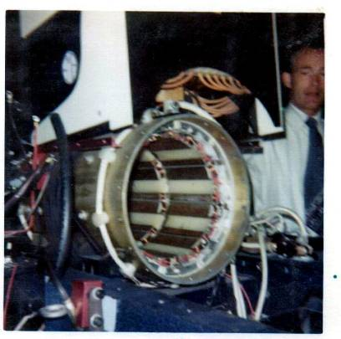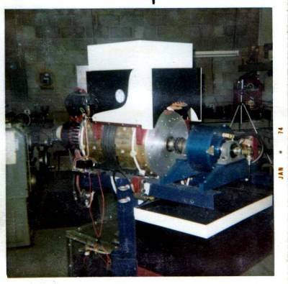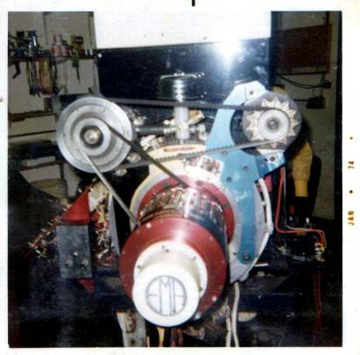

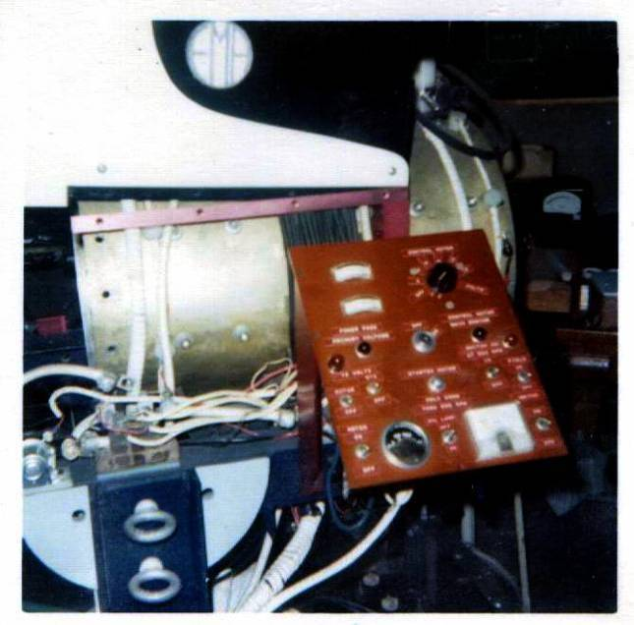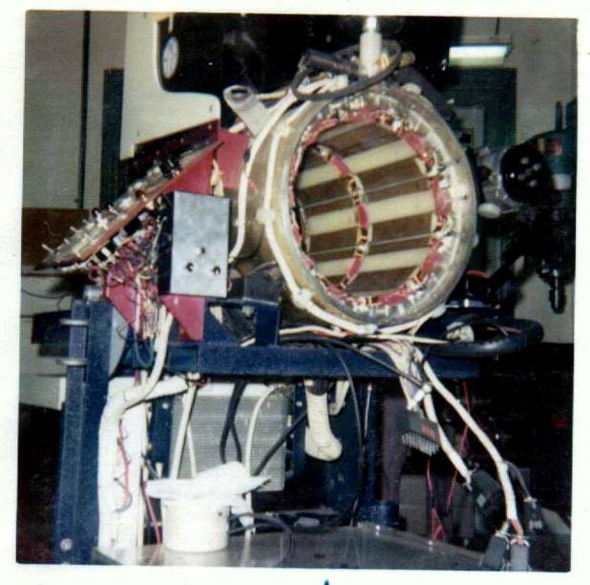

From: Dr. James A. Gray, Sr. [mailto:icyams@sbcglobal.net]
Sent: Tuesday, August 29, 2006 8:45 PM
To: Mckay, Mark
Subject: Re: Edwin Vincent GrayTimeLine.doc
Dear Mark,

Just a few items of interest . . . 1st, one of the first-family mentioned something that I do recall, that is that a Mr. Marvin Cole. My parents met him in the late 58-59 at a seafood restaurant on the Santa Monica Pier, Santa Monica. Marvin rapidly became a close friend of the inner-family unit. And he wore several hats (per say). He was a fabulous chef, my father used to call him "Pierre" because of his French/African-American heritage. He was also a wonderful artist, in fact, he had an engineering degree (mechanical I believe). Thus, we recall our father have Marvin over to our home many times to do mechanical illustration drawings! And as we think back, it was drawings of this type . . . clearly we do remember this! It came to our attention because of our Uncle Earl Whiting (father's sister's husband). He kept wanting to know more than my dad would allow him to know! Long story . . . not one to be published. However, when the Broadway Collision body shops came to an end and we moved on to Prescott, AR . . . so did this relationship end. I wish I could find this man, I have this hunch that
he may very well have been the missing link in knowledge! In fact, it wouldn't surprise me that Marvin would be in possession of all the drawings! I wouldn't be at all shocked to find out that he was the man dad kept in the shadows to protect the completed drawing project! He was very close to my father, and I believe he would/could be that loyal to him! The last I knew of his whereabouts was in Culver City, CA . . . where he had a business and residence. But again, late '59 would be the cut-off date, I can't recall ever seeing him again unless Dad secretly re-established their ties again in late '69-early '70's period. Out side of Marvin's technical drawing and art abilities (which were extensive) and cooking skills,
I couldn't remember anything else.
================================================================================

Dr. James A. Gray, Sr.
"Prayerful Solutions!"
Christian Counseling Services
1335 North Caddy Lane
Wichita, Kansas 67212
(316) 641-7029
====================

From: Mckay, Mark
To: Dr. James A. Gray, Sr.
Sent: Wednesday, August 30, 2006 5:36 PM
Subject: Edwin Vincent GrayTimeLine.doc

From: Dr. James A. Gray, Sr. [mailto:icyams@sbcglobal.net]
Sent: Thursday, August 31, 2006 1:04 AM
To: Mckay, Mark
Subject: Re: Edwin Vincent GrayTimeLine.doc
Dear Mark,

Read the red between the lines below . . . I'm trying to ascertain whether or not my father ever saw Marvin Cole in the 60s! If he did, it would not have been before the business in Van Nuys, California had begun in the mid 60s! This I am positive about! Something keeps gnawing at me about Marvin/Dad connecting . . . I'll keep working on it, maybe something will click yet! There's always hope! Sincerely . . .
================================================================================
Dr. James A. Gray, Sr.
"Prayerful Solutions!"
Christian Counseling Services
1335 North Caddy Lane
Wichita, Kansas 67212
(316) 641-7029

----- Original Message -----

From: Mckay, Mark
To: Dr. James A. Gray, Sr.
Sent: Wednesday, August 30, 2006 7:36 PM
Subject: RE: Edwin Vincent GrayTimeLine.doc

Dear James,

This is most interesting. Just when the trail got cold a very good candidate shows up for the Mr. X role. Now it is looking that your father might have been correct when he reported that he had learned how to "split the positive" in 1956 (or 1958). This give-and-take between Marvin Cole couldn't have happened before1958, simply because my father was struggling to promote his auto-body business the first couple of years. Besides, he didn't come to know Marvin till about mid 1958. Likewise, there could not have been any association after 1959, again, because of the shifting around of addresses. Also, Marvin worked for my father, he did the drawings as instructed by my dad. However, I do believe that Marvin aided my father with technical engineering terms. He never said he did it himself. A man of color at that! The Free Energy community is not to well known for ethnic diversity. A mechanical engineer with a gift for free hand illustrations, All of the drawings done by Marvin were free-hand sketched in order to capture dad's ideas/concepts! Then, mechanical illustration drawings were fabricated, followed by some hypothetical engineering drawings. None of these projects were anyone's but my father's from the get-go! Also, Marvin was always paid for his services. now this makes a lot more sense. And there was some friction between your father and his brother-in-law over the content and disclosure of these drawings as well? Now it is looking like your father went underground with his verification experiments almost from the beginning and largely sat on this information for the better part of 14 years. Maybe your father actually found the missing link that Mr. Cole might have been speculating about but never found himself. Again, he only helped my dad achieve his goalsI wonder what the technical circumstances were that allowed him to "put-it-all-together"? I suppose you wonder like I do as to what ever happened to Mr. Cole and what his and your father's relationship was after 1959.

Again, when and where was that explosive experiment done between the two garages that you and your brother had to clean up? Between two shop building
in the sand, on Losee Road in northeast Las Vegas, Nevada. Had to be in the timeline of 1963-64! A few experiments took place inside one of the buildings
on the concrete floor. Mainly because it was to blasted hot outdoors! Otherwise, he did them outside to eliminate probable fires.

I'm attaching the "official" biography of your father that comes from Peter Lindemann's book. This was the best information he could get in 2000. Obviously it needs some updating but I thought you might want it for you files in case you don't have it already.You know, I would love to know who(m) were the few men that had access to the inside circle . . . if anyone ever truly did! Maybe Dad waent it all alone! If so, no wonder his health faded fast in the end! That's a tremendous load to bear alone, but it was his choice for some odd reason to me! I just hope by picking my mental ccapacitor-banks (memory), we may all find a wonderful blessing!

Well, have a good Labor Day weekend. I'm going on vacation with my wife Liane to visit my daughter at Reed college in Portland OR. This is her last semester (finally), but then again when the daughter graduates from college she has truly left home and its hard to have to face the stark reality of the "empty nest" for real. Some how when she is going to school she really hasn't left home or so I like to delude myself. I'll pray for you and Liane, this is (was for us, especially me) very
difficult to process thorugh! My eldest daughter didn't leave home till she was 33-34 (?) and we were very close. We did lots of "volunteer" services together throughout the Wichita community. Linda never was the socila type, she'd rather sew, quilt, etc for the kids and grandkids! You know how that goes by now!
Anyway, when she (Verlinda) decided it was time to vacate the premises, marry and start a family . . . it was hard for a while. Say, I wish you folks a lovely trip and visit! Sincerely, James . . .

Mark

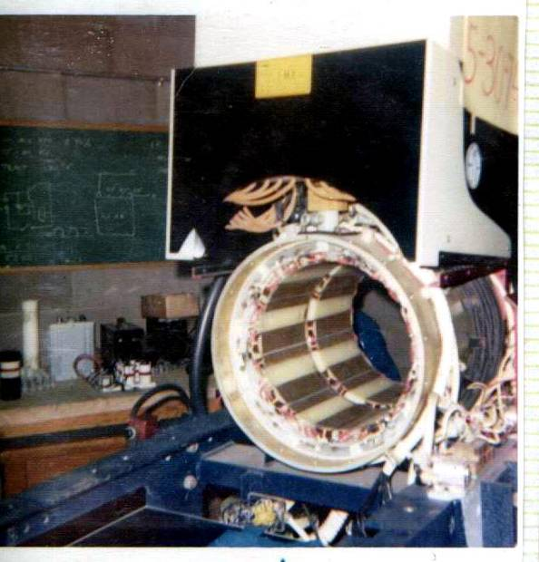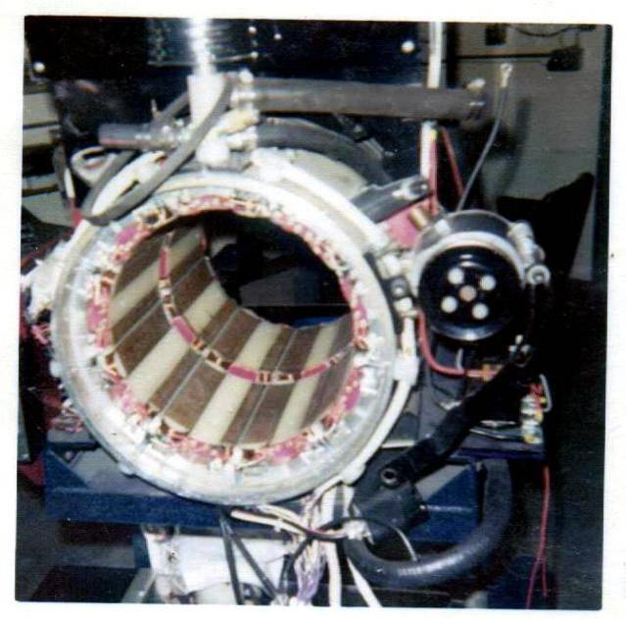

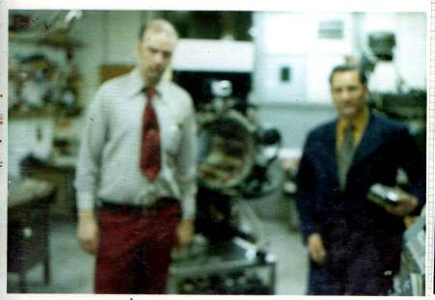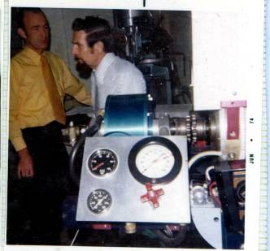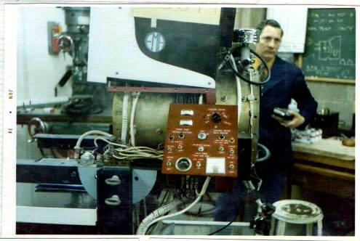

Hi Mark,

Good to hear from you, hope you had a nice holiday celebration!
As I have read your comments, questions and such, I responded
in RED type . . . Sincerely
========================================
Dr. James A. Gray, Sr.
"Prayerful Solutions!"
Christian Counseling Services
1335 North Caddy Lane
Wichita, Kansas 67212
(316) 641-7029
====================
----- Original Message -----

From: Mckay, Mark
To: Dr. James A. Gray, Sr.
Sent: Friday, September 08, 2006 8:15 PM
Subject: RE: Edwin Vincent GrayTimeLine.doc

Dear James,

Thanks again for the additional historical details and insights to your father's life and his relationship with Mr. Marvin Cole.

If I understand this correctly, then you see Mr. Marvin Cole as largely a paid specialist (artist/draftsman/illustrator) to further develop, on paper, your father's existing (or recently acquired) ideas. This is not uncommon. We have a substantial Engineering/Fabrication business in Spokane that makes custom canal digging equipment and other large custom construction equipment. The owner, R. A. Hanson, has on his staff two full time technical illustrators that quickly sketch drawings for Mr. Hanson when he is in the initial stages of a new project. His approach seems to work. Of course he has the $$ to hire such talented people.

If Mr. Cole came along and provided these services to put your father's ideas down on paper, then there is the chance that the original "kernel" of the technology might have come along some time earlier. If your father was drawing motors (or rather having then being drawing for him) did he ever display an interest in electric motors before (to any of my siblings, the answer is a resounding NO)? I wonder what the motivation was for developing a new kind of motor? any ideas? (YES! As I have explained to other individuals, my father's original "intent" was to eliminate power-poles/lines, dams (hydraulic and nuclear) and public untility companys! His hope was to devise (create) an electrical powerplant for every home! He wanted to place in every house an independant electric generating plant, my as you have an A/C system, hot-water heater, garbage-disposal, etc. He hated to pay what he felt were unreasonable utility bills! This much I can recall clearly. He also felt that it could be accomplished, and be self-sustaining at the same time.)

Was you father that special kind of person that would have sudden flashes of valuable inspiration? Like suddenly knowing where some important item was lost, or just knowing which store had the best sale for needed family goods. Perhaps solutions to challenges at work or home would just suddenly appear as a plan of action? I know this quality is hard to evaluate, but sometimes it can be discerned in individuals. (This concept was ever so present with him, in that NO he did not keep any type of running record regarding store values. Least none that I recall with the exception of groceries. My mother and father did the marketing every weekend . . . together. Otherwise, he seemed to come from a family-stock whom would brainstorm for a fix at hand. What is the old saying, "necessity is the mother of invention" . . . well, something to that effect. My father was always very ingenious when he thought of something which would make life better (i.e., like the idea of a better mousetrap). I suppose that's why he was so very good at his craft working with automobiles! For example, in the 60's when custom car were beginning to hide their antennas in an effort to clean-up the exteriors for a classier finish, he took an electric-antenna and created what is termed the "tear-drop" prcedure. He could locate it anywhere on the exterior and the antenna could be raised and/or lower as needed from a button inside. He was quite well known for his cleavor creativity in the industry. He was this way at home too! He rarely ever paid anyone to do anything, he was very self-sufficient. Ih he could dream it . . . he would build it! Basically, this was his credo/motto for life.)

The technical evolution of this process suggests that the power converter was developed first and then a motor was built to take advantage of the enormous energy gains. However there is the possibility that your father visualized the pulse motor concept as a new idea in its own right and then ran across the anomalous power gains as a fortunate happenstance ("Happenstance," for the most part, that's how "things" (for the lack of a better word at the moment) happened in my father's life. Nonetheless, He seemed to be like an old fashion "perk-o-lator coffee pot, something was always clicking with him. There never was a "turn-off" switch!)? This would explain why he hired an electrical engineer to look into the operation of the circuit (1971). I doubt if Mr. Hackenburger ever figured out the actual source of the excess energy. So, which came first the Motor or the Power converter? There is a good chance that your father never started out looking for "Free Energy" but was looking for a more efficient DC motor. His novel approach to the pulse motor might have dropped the energy gains into his lap. When he realized this, it was probably a new ball game. If this line of thinking is correct, then Dr. Tesla wasn't the the original source for this technology, even though the technologies might be related. (If I had my guess, I'd say the "Power-Converter" came first because he understood, or at least had some knowledge in this area. Why I say this is that he was conituously working/reworking mechanical/electrical apparatus for machinery, cars, trucks, etc. Converting power from A/C to D/C, or vica/versa for application!)

So, your father was only 33 (33/34) when he met Mr. Cole. Well, it is probably safe to project that your father continued thinking about this idea that inspired him for 10 years if he was willing to pay someone to draw it up.By 1964 he was doing a few hardware experiments as time and money would allow ( I'm not sure that he was doing these experiments or just for entertaiment. This could be the actual time-zone in which all this began to "click" with him! Perhaps it was within these experiments that some notion came to his mind, you know, kind of like, Ford's "light" coming on!) . If Mr. Cole just served as an illustrator and technical consultant, then there was no real business reason for your father to see him when he moved back to California Precisely!. If he was indeed concerned about technical secrecy at this time then there would have been substantial grounds for not seeing him. (My thinking exactly!) I assume that the interested brother-in-law was not around as much in these new business locations after 1958. (My Uncle Earl Whiting was in the airforce. I believe he was a pilot of a B-52 Bomber for Startegic Air Command (Staff-Sgt) . . . thus he was pretty busy elsewhere most of the time.)

To the best of your recall, when did your father start talking about his investigations or any success he might have had? I get the impression that a lot of work from 1958 to 1969 was mostly hidden (twas NOT "hidden", one or more family members were around him "All-The-Time" He worked from early morning till late night, nearly every day! ALWAYS HIS FUNCTIONING WAS ABOUT THE BODY-AND-FENDER BUSINESS AT HAND! None of us can ever recall an instance of his involvement with this invention . . . physically and/or orally prior to late 69, more likely 70ish!) from the family for unknown reasons. It sounds like he didn't have a lot of spare time any way. There could have been a real change in attitude when he realized he was dealing with "Free energy" and not just an improved DC motor?

In the possible chain of events, your father would have had to have a working demonstration circuit before he could collect a group of "insiders". Furthermore he would have had to have a working motor that unquestionably demonstrated "Free energy" to get the level of funding that is displayed in the 1970 to 1973 period (about 1-2 million dollars). (One would think so, but just perhaps he sold the idea/concept to a few early-comers from simply the sketches and his verbal pre-presentations! He was quite gifted with the "gab"! And if he wanted and/or believed in something, he was genuinely a persuasive personality! Quite capable to accomplish his goal(s)! His brother and sister would often muse over this fact, saying things such as "he can sell ice to the Eskimos!" He could tell a false story, then get you to agree with him in front of another . . . that it was true!)

Were there any "insiders" that you know of in 1968 or sooner? (None.)

Can you recall just what you "cleaned up" after the explosion? Was it a rotary motor device, or was it a collection of coils, spark gaps and large electrical condensers or maybe other stuff. An explosion in this kind of work normally implies a catastrophic failure of a capacitor or a wet cell battery, but this doesn't mean that is what actually happened. He could have had a transformer failure. (All I can recall are burnt wires, some coiled wire spools and chard black tape and metal. That's been such a long time ago. And at the moment, it didn't seem too big a deal to us/me (kids). It just seemed like fun for my father! We didn't questions, he never offered any.)

These are just some random thoughts and questions in an attempt to find the source of this breakthrough. Perhaps we will never know for sure, but its worth the effort to recover what we can.

Again I appreciate the time and effort you have put into this project. Attached are a few more photos. Do you recognize any of the men in the photos?

Mark

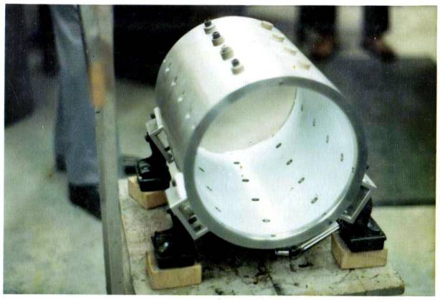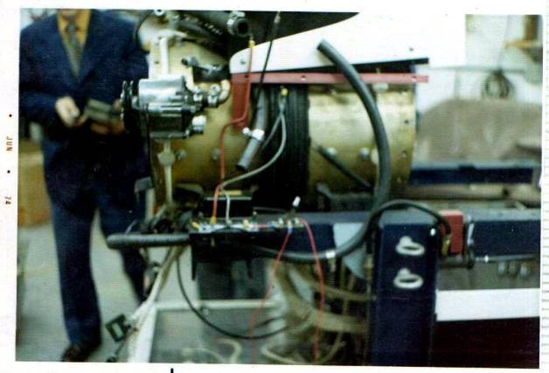

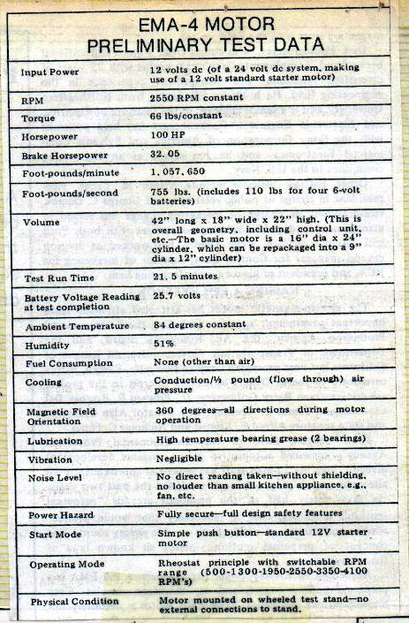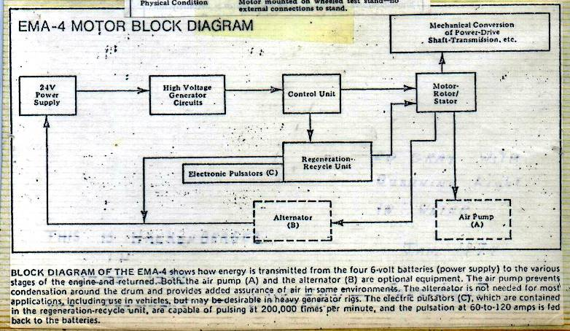

----- Original Message -----

From: Mckay, Mark
To: Dr. James A. Gray, Sr.
Sent: Friday, September 15, 2006 7:29 PM
Subject: RE: Edwin Vincent GrayTimeLine.doc

Dear James,

Thanks so very much for the time your have taken in providing me with the very detailed responses to my many random questions. I shall respond in detail later after I have considered the material. For now, it appears that you might not have a copy of the 1973 article by Jack Scagnetti. This is the foundation article for which much of your father's technical "Heritage" and present public image comes from.

There is a photo of him receiving the "Inventor of the Year Award" on page 4. The article says that the lady in the photo is his wife Evelyn. Is this correct?

Mark

From: Dr. James A. Gray, Sr. [mailto:icyams@sbcglobal.net]
Sent: Friday, September 15, 2006 7:42 PM
To: Mckay, Mark
Subject: Re: Edwin Vincent GrayTimeLine.doc

Hi Mark,

Interesting reading, but NOT entirely accurate information! One: the gal shown in the photo-opt with Dad is the infamous Renata (Rene') . . . NOT Evelyn! Really, that only shows that Jack didn't get all the facts correct. None of us siblings recall any such person, though there may well have been. But not this gal! She IS Renata, Dad's child-bride and his 2nd wife . . .
My mother Geraldine Mildred being the 1st.

Another item of interest is that the lead-lines (2nd sentence) says, "It's inventors say . . ." Now just whom are they referring to? I suspect that Fritz Lens is implied in this statement, but I agree there were no other inventors, just assistants I say its Dick Hackenberg! I would include him to, but this is just for the sake of the article. It is rumored that he did make some design improvements to keep the storage batteries from exploding. I've always insisted that he knows more than he can/wants to say! But WHY?! Because your father had a legally binding secrecy agreement with him that carried some stiff liquidated damages clauses. This is common in emerging technologies and are upheld by the courts. It is he that taught my father the "engineering technical jargon/lingo!" No doubt. I still insist that he (Dad) did not have this knowledge till the time of this relationship! I agree Until he formed this relationship with Hackenberger, he (Dad) didn't know how or
what he was dealing with in reality. I suspect that your father was very aware of the "What" (at least what it took to make it) and real weak on the "How it did it" Thus, Dick was Dad's closest inside man! And well he should be, neither one of them really knew where all that energy was coming from. Even if we had that equipment now it would take the Physics years to agree on anything.

Any idea how long Mr. Hackenburger and your father were associated? Do you know when Dick passed on?

Also, if you'll do the legwork, you'll find that my father was only in the US Army for a few weeks. Not a year! How do I know this, well, had he been in for a year, he would have been legal age and able to retain his status therein. Thus, he was never involved with the "advanced" anything, let alone the "advanced engineering" program! Think it through . . . he was fifteen (15) with an eighth-grade education! What did he have to offer this program? What could he have offered? My understanding of this elite group is that certain credentials had to be presented for eligibility! He had absolutely NONE! He didn't even finish "bootcamp"! His age was found out immediately after "boot camp" initiation, simply because of his lack of final education (high-school).

This make rational sense. I never could see how he could have been in "Advanced Engineering" school. That is for officers at Ft. Belviour and even then its for Captain grade or higher. I should know I was there. I'm sure the Air Force has a similar program. Recruits need to finish their basic training then their MOS training before they can even consider anything "Advanced". Normally after demonstrating two or more years of outstanding service in their technical field and re-up for a serious time commitment. Education in the Military is not really free.

Contrary to high-hopes of many folks, my Dad did not have a long history of education and/or involvement with this technology until the 70's! As well, in 1961 (next to the last paragraph on page five-5) he could not, did not conduct any tests on any invention(s) because he was working for Brad Bradford Auto Body in Littleton, Colorado! This is another fabrication of history for the investors and media! I'm so very sorry! No need to be sorry, the real story is even better than the the accepted history There was no time/room for his so-called experimentations at this small location (Mr Branford's business)! Mr and Mrs. Bradford were very sweet and compassionate people who helped our family with special gifts of clothing and foods, etc! Why, because working for other's in any labor field is anything but profitable! Especially in the early 60's. Edwin V. Gray, Sr. was a hard working laborer and a good family man at this point in his life! But he had no perks, no extra money and no extra time to manufacture or test hypothetical Machines! It just didn't happen! Which makes the story so much more interesting. The 1961 date used in 1973 gives this technology some respectable history of being well tested and mature, with all the bugs worked out and all the optimizations made. I'm sure that was far from the actual case. You can imagine how the press would read if he said "I just stumbled across this a few years ago". Now matter how good this stuff demonstrated I could see investors saying, "Lets just watch this for a while longer". Your father had to make this breakthrough seem "well seasoned" anything less that this would have greatly reduced his options at venture capital. Besides who was going to call him a liar at this point? who could refute him? so he may as well use a date that is recent enough to be "modern" but old enough to be stable. Apparently 1961 was the magic number.

Tell you what I'm going to try and do . . . I am going to contact IRS to see if I can get a copy of my father's "tax returns" for the last twenty (20) years of his life. If I am successful in doing so, I am more than certain it will confirm my established timeline! And a great deal more! It will reveal his financial status both: personal and business! Pray, this could settle an immense amount of questions or should I say . . . assumptions and misinformation?! I certainly have no doubts about your reports of the actual history. The 1973 reporters were just doing a single pass interview for some local tabloid magazines. They wrote down what they thought they heard and probably massaged it at that. I'm sure that there were some good business reasons for your father to fabricate the past a little (or a lot) to provide some better press. I know my father did a lot of that in the Carnival business and thought nothing of it.

There is more to say regarding Jack Scagnetti's story, my Dad's invention(s), his dealing with the public and those who were allowed to be close to him . . . But later for these statements. Again, with something so vitally important to the world community, why hasn't someone, anyone, especially those who write columns and articles regarding my Dad, his history/allegations and such . . . investigated his background? Since 1973, Peter Lindemann's book is the only real writing that has been done about your father. All the rest has been e-mail posts and copies of the original 1973 articles. Most anybody who has a real interest in Free Energy is into the technical aspect of the circuits and not the historical accuracy of the mythology. They would rather spend their time with a solder gun building the next larger Tesla Coil than spending time searching for the hard to get facts. Unless such a search would produce additional technical information- they are not interested.

An internet search will yield copies upon copies of the same six or so unpublished documents. I've spent hours searching this medium and have found precious little. Unless something has come along in the past year every thing written could be held on 20 sheets or less. - And a lot of that would be speculation.

Everyone's life is an open-book, public speaking! Almost everything is subject to public record . . . thus, open to the public scrutiny!

Sincerely, Dr. James A. Gray, Sr.

Dear Mark,

I just found this letter from you stuck in my files!
Don't know how I missed it!
I'll write and discuss it's content as soon as possible, but it may be a few weeks!

Sincerely, your friend James . . .
=============================================================
Dr. James A. Gray, Sr.
"Prayerful Solutions!"
Christian Counseling Services
1335 North Caddy Lane
Wichita, Kansas 67212
(316) 641-7029
====================
----- Original Message -----

From: Mckay, Mark
To: Dr. James A. Gray, Sr.
Sent: Tuesday, September 26, 2006 8:57 PM
Subject: RE: Edwin Vincent GrayTimeLine.doc

Dear James,

I have still been pondering your historical revelations. I still have a hard time understanding how your father appears to have accomplished so much in such a short period of time. All I can come up with is that he was working on this project secretly from 1964 to 1969 as money and time would allow.

But why so much secrecy? If it was just intended to be a novel motor then no big deal. This points to the idea that he had the foundation for a "Free energy" device in 1958 and knew it. He hired Mr. Cole to put his more advanced ideas on paper. Most likely there were some technical issue(s) that hindered the actual construction progress. Or maybe the financial upheaval was the real impediment. Whatever it was it was resolved in that 1964 to 1969 time frame. As soon as he could demonstrate the Black Box power inverter he was off and running. According to documents that Peter Lindemann has this device could yield COP's of 81 (Coefficient of Performance). The demonstration for this device is pretty effective. A small motor cycle wet cell powers 1400 watts of load (light bulbs, motors, Electronics) for about 8 hours. I certainly would have invested if I were there.

This still doesn't explain where he got the inspiration from in the first place, or why it never made it to market. We can make some pretty good guesses about why the technology didn't get to market, but we may never know where the original came from. Where ever it was, there is a strong chance that he knew what it was when he saw it and was willing to pay money to document it.

There are some questions I have about Renata that might help explain some of the events in this time period.

As you mentioned, there appears to be a considerable age difference between your father and Rene. In the 1973 "Inventor of the Year" photo your father was about 48. She doesn't appear to be much older than 30. Do you know what the actual age difference was?

Any idea as to how they met? Was she an employee? Perhaps a waitress at the local sandwich shop? I'm sure their meeting is a story in itself. It is rare that couples are established with that kind of age difference. Of course, your probably know far more than I on that issue because of your business background.

Is there a possibility that your father disclosed his successful research to her and that she saw $$$$ with a bright future. So much so that Cupid's Arrows just happened to be so much more effective?

It has been said that Rene's father was Fritz Lens and your fathers mechanical assistant. Is this true that you know of? It would seem like an in house thing to do to hire the wife's father to help keep sensitive matters in the family.

Do you know what Rene's full maiden name was? Is she still around? Did she have a previous marriage prior to your father that you know of?

Your father died in the company of Dorothy. This implies that he and Rene split company at some time in the past. Do you know when and where this might have been and what the circumstances were? Perhaps her dreams did not blossom the way she thought they should.

IF their separation was hostile then the decline of the technology could have been largely a result of ex-marital warfare. She would have wanted half of the value of his accomplishments, since she was their since the beginning and it would have been hard to claim separate estate assets. He would have had to play the role of the impoverished inventor and hide his assets where he could. This would have complicated his quest for manufacturing a single production run. Since she was a business insider she probably knew what the game plan was, before any break up took place. If the relationship went South before the big payoff then I can see how the business plan could have been altered big time.

Maybe dark clouds were forming in the relationship in the 1976-1978 time frame, but didn't actually result in physical separation for years after that. A love gone cold could have been even more devastating than the loss of two primary investors. What could have made matters worse would be that she was also a business partner. If she had the inclination she could have wrecked havoc to his administration process, bank accounts, contacts, bills payable, contracts, technical records, licenses, on and on. I don't know if this happened, but it could have - the potential was certainly there.

There are good reasons that the common wisdom states "Don't get your Honey where you make your Money"

Attached are a few more of your father's articles from 1973 to add to your collection if you don't already have them.

Thanks again for sharing the Truth. Some further comments are below.

Mark

----- Original Message -----

From: Mckay, Mark
To: Dr. James A. Gray, Sr.
Sent: Tuesday, October 31, 2006 6:28 PM
Subject: RE: Edwin Vincent GrayTimeLine.doc

Dear James,

No rush. I've been keeping quite busy in exploring another avenue of research possibilities. I thought I would just share with you some of the work I've been doing so that you can see that some progress is being made.

Mark

Hi Mark,

As I briefed all that enclosed, I am amazed at my father's geniouswhen it came to creativity!
I only wish his penchant for women hadn't distanced him from his first family, so much would
have been different! As I read and re-read these article on his inventions, of which I try so
diligently to understand . . . but to bot much avail! Why is it that brilliant people such as he was
have so much difficulty in interpersonal relationships?!

It is my sincere hope that someone like yourself may unlock his secrets and share them with an
over-due world of such scientific needs! Thank you for continuing to share and explain what you
have researched. It is/has been very stirring!

Sincerely, James

PS: For some reason or another, April is unreachable by e-mail for our family. Seems she has
either blocked us or generated another e-mail address and desires not to share it. Does she
respond to you? Just curious.

Tue 11/7/2006 1:54 PM

Blessings family and friends . . . in Jesus' name!

Today (Tuesday), after my third trip to the Urologist' office, here's the report:

Out of 19 biopsies of my prostate-gland, one quadrant had some unidentifiable cells. So, they have been sent to a research facility for determination. All other regions were benign!

Linda and I asked if what was being said is: are they cancer cells to be confirmed, or are they cells to identified only? We were told that there were just a few cells that needed to be identified
for completion of diagnosis. Thus, they could range from other forms of infection, inflammation, certain types of "itisis" or cancer. In the event they are cancer, they will discern which type it is.

Whatever these cells are, we'll know what and ho to deal with them then. It'll take one to two weeks for the final results

Well, we know that all things are in our Lord's Hands and in His hands is healing power, and all "good" things come to us through and by our Heavenly Father! Amen!

Let us continue to pray for a good final report in Jesus' name . . . Amen!

Dr. James A. Gray, Sr.

----- Original Message -----

From: Mckay, Mark
To: Dr. James A. Gray, Sr.
Sent: Friday, November 17, 2006 7:18 PM
Subject: EV Gray Historical REsearch

Dear James,

I've made contact with a Mr. Joe Gordon of Grand Prairie, TX. He is an attorney who is in the oil drilling and exploration business. He claims to have worked with your father from 1985 till his death. Perhaps you know him? I talked with him for an hour and realized that he was the sole source of the Dr. Papov connection.

According to Mr. Gordon, your father told him that it was Dr. Papov who introduced him to this technology. The rest of the story claims that this happened in Florida while he was working on a secret NASA project. I know this is not correct but I was not going to argue the issue with Mr. Gordon at this time. What is interesting is that Mr. Gordon claims that this took place in 1969. John Bedini has discovered that a Dr. Alexi Papov does exist and was a physicist who did research with electron flow in spark gaps. I don't know when or where he did his work or if there is a real connection to your father. Its just as likely that his name was pulled from a technical magazine.

What this establishes is that Mr. Gordon is the source of this particular story about your father's history, which he considers to be the truth as it was told to him. Mr. Gordon worked with Ken Hawkins and Norm Wooten to recover the EMA4 and EMA5 motors in 2000. Mr. Gordon told them the story as best he knew it. Norm went on to give the 2001 Keeley Conference lecture and write the internet article. So now this partially fabricated story has almost become history.

Mr. Gordon claims that he and your father merged their respective companies (Ztech and Western States Oil) in about 1986. They leased a building in Grand Prairie, TX and used this as a base of operations for a few years. Mr. Gordon has a promotional video of the work your father had developed up till that time. I shall forward you a copy when I receive one.

Apparently a bank account was set up in the Cayman Islands and another individual was hired on commission to sell stock in this newly merged company - off shore. He was actually selling stock in the US where it was not listed with the SEC. According to the story about $50 million in stock was sold. Of course this broker took his healthy commission (and maybe more) and moved (or escaped)to Israel.

According to Ken Hawkins, Dorothy went to the Cayman Islands to withdraw the money but was put in jail. Apparently there was some stock fraud investigation going on but no one would pay to have her extradited back to the US. She was some how released and most likely didn't try that again. The story goes that the bank swallowed all the remaining money just like the Swiss banks took all the money of the Holocaust victims. So this is where the story about all the millions comes from. Maybe there is some substance to it. I'm sure the technology was well worth it.

Mr. Gordon seems to think that your half brother Mark Gray lives in Spokane. I kind of doubt it, but just in case I'm calling the two Mark Grays who live here.

Mr. Gordon's business partner was killed by a semi-truck while he was dirt biking in California. This was just a month before your father died. Mr. Gordon believes both events were suspicious. This is where the MIB stories come from, and again may have substance.

Mr. Gordon claims that he and your half brother Mark made a presentation at the Balclnes Research Laboratory at the University of Texas at Austin. He recounts how the facility were cordial and supportive but maintained that if they ever attempted to market this work that the big battery companies at the time (Delco and Exide) would take them to court for every kind of patent infringement they could find or makeup. Which is probably not far from the truth. It's to bad they didn't take a more serious interest in the fundamental science which is the foundation of this technology. Another opportunity lost.

Mr. Gordon also maintains that he approached Ford and GM by mail. They wanted him to send them the equipment for evaluation. Well, that seems to make sense all the way around. I would think that a presentation by mail would be a long stretch for something this novel.

Mr. Gordon also claims to have worked with your half brother Ed in some of the presentations he was doing around the country

I'm sure there is a lot more information to get and a lot of corrections that need to be made, but at least there are a few people left who remember something.

Just a little up to date note.

Hope things are going well for you.

Mark

My, O' my! Have I something to say about this story! And Mr. Joseph Gordon!

Much of what he says is simple poppycock, especially about Mark and Ed! Ed referred to is the eldest of the original seven (7) children by Dad's first (1st)wife Geraldine Mildred O' Curry! There is 10 months, two and a half weeks separating our ages. Mark, as referred to is my youngest brother of the same
genealogical stock. There is NO half (1/2) brothers by those names. Fact is,Eddie is a "junior" (Edwin Vincent Gray, Jr.), Mark is simply our youngest sibling.

George whom purchased my father's shop in Van Nuys, CA, is a cousin whom my parents had legal custody and brought from the great state of Maryland when we relocated in 1956. He was never adopted, he chose not to be.

Now, as far as half (1/2) brothers are concerned, they would be Patrick and Ricky. And one half (1/2) sister . . . April all comprise the second family of my father's! There are no others. In fact, Ricky was a child out of wedlock by his mother Renata during her teen years (I believe latter portion of high school). However, as I believe to be truth, my father did adopt him!

Anyway, before I get too far off track, Patrick (1/2 brother via 2nd marriage) is the one who has given several presentations in Texas to the "New Energy" discussion forums. Not Mark. Now, I believe that Patrick has more info than letting on to the first family, and maybe April . . . But if they do, it is obvious they know not what to do to promote it! Or, perhaps they are afraid of meeting the same follies of our common father did! That . . . I can/could very much understand! How about you? Ricky was never truly connected to anything.

Well, its late and I'm tired. As for Mr. Joseph Gordon . . . more later. He has either a considerably failing memory, or, is very selective and clever. I went through a great deal of trouble a few years back tracking him down regarding my father's inventions. I have addresses, telephone numbers and his "law bar" number. But when I called him on the telephone, he insisted not to be Mr Joseph Gordon (of which there is only one in his area bar listings). Curiously, would you share his address and phone number that I might cross reference them with what I have!? He claimed he never knew my father, and that he wasn't the one I sought! Again, he was/is the Joe Gordon involved with my Dad.

Well, good night for now, I'll try to reconnect sometime next week.

Sincerely, James

PS: If you want Ed/Mark's telephone numbers, just ask . . . they're not hiding from anyone.

Mon 1/1/2007 3:03 PM

"Have A Happy New Year . . . 2007!"

I pray that we all have a sensational year in finances,
health, happiness, and spiritual-life!

Remember, when it comes to God:
-you only receive when you give,
-you only reap what you sow,
-you only have friendships when you are a friend,
-you only get blessed when you become a blessing . . . to others!

AND . . .

+You Only Receive "Salvation" by:
* admitting you are a sinner in need of "forgiveness",
* calling on God to forgive your sins,
* believing on Jesus as the Son of God,
* acknowledging His work of redemption on Calvary's Cross,
* asking Jesus to be your Savior . . .
- Then take Him into your heart, and let him be Lord of your life!
=====================================================
Rev. Dr. James A. Gray, Sr.
"Prayerful Solutions!"
Christian Counseling Services
1335 North Caddy Lane
Wichita, Kansas 67212
(316) 641-7029 (c)
(316) 721-5104 (h)
====================

Sincerely, your friend in Christ Jesus,

Rev. Dr. James A. Gray, Sr.

Sent: Fri 4/6/2007 4:30 PM

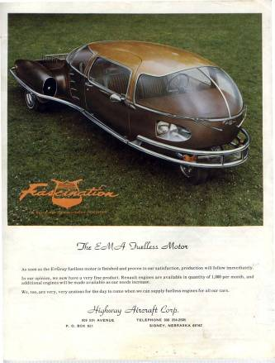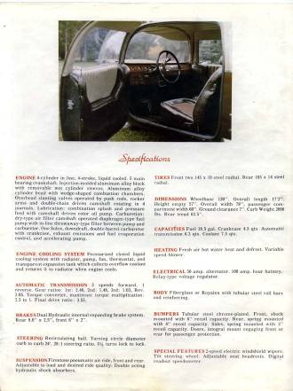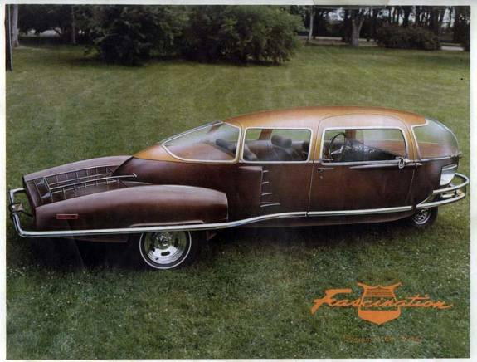

Dear James,

Here is a newly recovered piece of historical information that was just posted by Gary Bedini to the Tom Bearden site. This is the car that the 1973 fueless Motor your father made was suppose to go into. If you have any knowledge about what happened to this venture with Mr. Paul Lewis and the Fascination car I sure would like to add it to our collected history.

The last photo is my latest efforts with bench top experiments. This month's theory is that to build a Free Energy Machine you need to start with a very dead car battery. How is that for thinking out of the box? A research friend of mine in Australia claims that the circuit under constructions cools its capacitors by 3 degrees while operating. If this proves reproducible then we may finally have some experimental evidence of "Cold Electricity".

Have a restful Easter.

Mark McKay

Sat 4/7/2007 8:43 AM

Where can I view the article on the Australia "Cold-Electricity" experiment?

Also, the Lewis' car of '73, was it an "egg" shaped, three-wheeler?
If not, do you have a picture of it? Either way, I 'd love to have
a picture of the Lewis auto!

Dr. James A. Gray, Sr.
"Prayerful Solutions!"
Christian Counseling Services
1335 North Caddy Lane
Wichita, Kansas 67212
(316) 641-7029 (c)
(316) 721-5104 (h)

From: Dr. James A. Gray, Sr. [mailto:icyams@sbcglobal.net]
Sent: Tuesday, April 17, 2007 9:09 PM
To: Mckay, Mark
Subject: Re: Still Working on the EV Gray Saga
Hi Mark,

Indeed I've turned my P/C inside-out affording to locate my work! O' well!
I'll just have to sit back down, re-read your material and rethink my responses for you!
The vanishing SAGA is reminiscent of the old "Twilight Zone" show of the 60s! POOF!

Your humor is well timed and appreciated! I've had a very hard past week and a half!

The Fascination pictures all came through wonderfully, and YES, I recall this automobile
and it's owner. That is to say, I remember my father fusssing about this fellow attempting
to commandeer control of the EMA motor! But at the onset, Dad was excited over the
possibilities of a mutual resolve . . . a resolve which never came to fruition!

As to the "Time-Line" which I wrote for you, please send me a copy of it. Reason? To run
it against some new notes I've found. Some of which were noted in your "lost" manuscript!
Not to worry though, I'll get back to another rewrite/additions soon.

Sincerely, Your friend . . . James

From: Mckay, Mark
To: Dr. James A. Gray, Sr.
Sent: Wednesday, April 18, 2007 10:29 AM
Subject: RE: Still Working on the EV Gray Saga

Dear James,

Here it the timeline you sent me. I must admit I was amiss when writing the "Evolution" condensed history. Some of my dates are way off as you have probably noticed. I was working from memory on a different machine. Any additional information about your father's technical interests prior to 1969 would be helpful in understanding "What happened". If you have some theories of your own be sure and add them as they are probably more valid than my speculations.

Thanks again for all the effort to document this important history.

Mark

Wed 4/18/2007 10:44 AM

Dear Mark,

It is my privilege and honor to assist as you endeavor to write in honesty and accuracy
regarding my father's life and accomplishments . . . good, bad and/or indifferent.

Sometimes truth is greater, or at least more interesting than fiction! Thus, this man
Edwin Vincent Gray: defender of his country, husband, father, provider (greatly so),
socialite and inventor! And so, I'll return to aiding with what I am able, while always hoping
that somewhere someone may be able to reconnect-the-dots of Dada's mind and works to
give to the world a product which will revolutionize the technology of humanity on every
scientific front!

Thanks for remitting the original "Timeline", I'll compare it to my notes as I rewrite.

Sincerely,

Dr. James A. Gray, Sr.
"Prayerful Solutions!"
Christian Counseling Services
1335 North Caddy Lane
Wichita, Kansas 67212
(316) 641-7029

From: Mckay, Mark
To: Dr. James A. Gray, Sr.
Sent: Monday, April 23, 2007 6:36 PM
Subject: EV Gray New Video recovered 1986

Dear James,

I have just received a 1986 Video that shows your father when he was 60 demonstrating his equipment at that time. It is in color, of marginal quality but something different.
Apparently your father also had a Patent In the UK. I haven't been able to watch the whole tape since I'm at work but will concentrate on it at home this evening.
I shall make copies and forward you some in DVD format in a few weeks. Would your other family members want copies as well? Perhaps I should see the whole tape first, but the first 7 minutes looked very interesting.

Mark

Hi Mark,

In all sincerity, I believe they may all enjoy having a copy (1st family)!
Patrick, April and adopted brother have everything they need (supposedly)!
However, if you'll send me one for each, I'll pass them on.
I'll check with them over the next few days to be certain!

Dr. James A. Gray, Sr.

From: Mckay, Mark
To: Dr. James A. Gray, Sr.
Sent: Friday, April 27, 2007 3:33 PM
Subject: RE: EV Gray New Video recovered 1986

Dear James,

Here are some additional shots of your father. There are some other young men in the one photo. Do you recognize anybody, family perhaps?

Mark

Dear Mark,

Yes, I do know the identity of the two young men in the pictures!

The tall, dark haired fellow is my youngest brother Mark (6th born, 4th son of 1st family)!

The shorter, blond haired young man is Patrick (1st born, only son of the 2nd family)!

Interestingly enough, I've always said Mark knows more than he's been sharing, and as always, Patrick has, and continues to know more about Dad's works than the 1st family!

However, Patrick was quite young in these pictures, approximately 18-19, while Mark
was approximately 28-30 in age. I need to know dating of the video tape to be certain.

I was never aware of these two cordially worked together with our father on his enterprises!

Well, you live, and, you learn! Can I get an Amen on this?! LOL! Dr. James A. Gray, Sr.

From: Mckay, Mark
To: Dr. James A. Gray, Sr.
Sent: Friday, April 27, 2007 6:33 PM
Subject: RE: EV Gray New Video recovered 1986

Dear James,

The date on the Tape is 1-18-86,

There is also as news clip about the first Shuttle disaster, where it blew up just after take off. So in that time frame.

Maybe you can send him these photos and see if it jogs his memory a little. To be that close to the equipment he must know something about its history.

The older man identified himself as Joe Gordon, whom I have spoken with on the phone. He is in Texas. I need to talk to him some more and get more details on events in the 86 to 89 time frame. Looks like a lot was going on then.

Mark
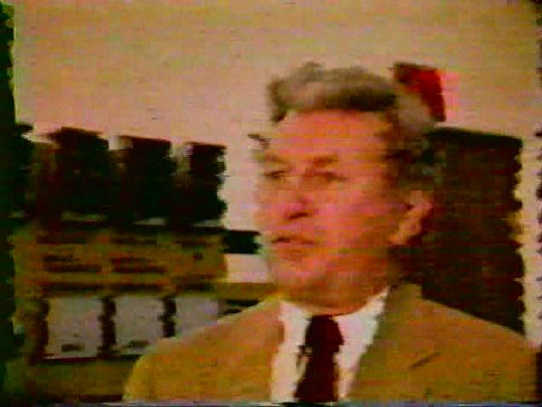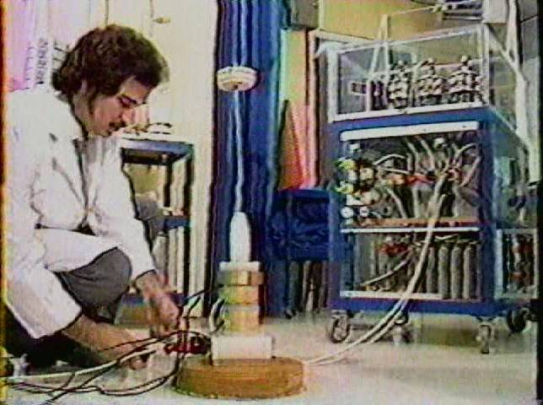

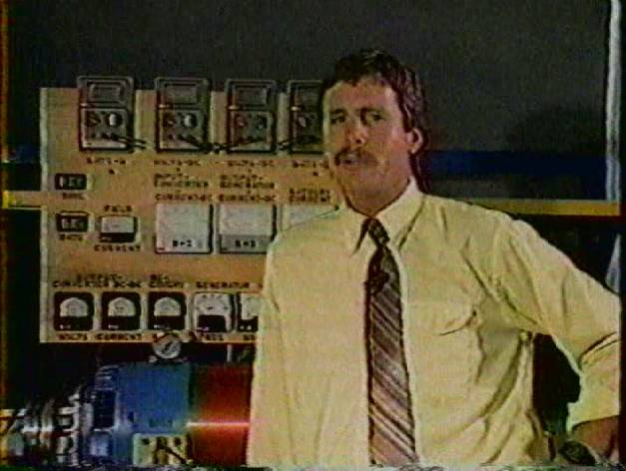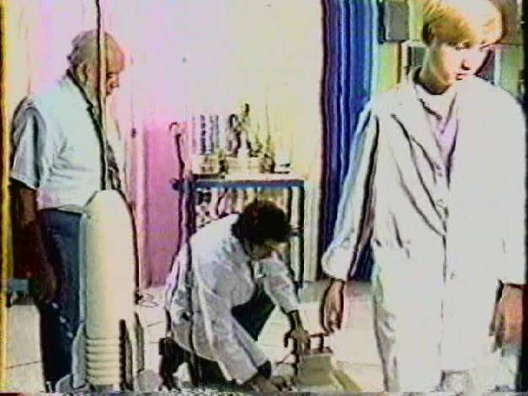
Fri 4/27/2007 6:41 PM

Thanks for the pictures; however, their clarity is quite poor!
Seems as though they are too large, too expanded!

I believe Joe Gordon is the man in the rear of picture #3, I'm just not sure!
Then again, it he may be the one in frame #2! I'll send them to Mark to see
if he can identify either of them!
Dr. James A. Gray, Sr.
Fri 5/4/2007 1:21 PM

Hi Mark,

Just a note to say I "received" the six (6) disks (6), and I'll review one
as quickly as possible.

Also, I will rewrite my last response and, my review of the current disk too!

Sincerely . . . James

Dr. James A. Gray, Sr.
"Prayerful Solutions!"
Christian Counseling Services
1335 North Caddy Lane
Wichita, Kansas 67212
(316) 641-7029 (c)
(316) 721-5104 (h)

Fri 5/11/2007 6:25 PM

Dear Friends in Christ Jesus,

Today I saw my 2nd orthopedic surgeon for another view on my right hip problem!

It twas neither enjoyable or encouraging. My hip is under serious deterioration
from both 15 years of wear and the fall I took at the end of February.

I've been instructed to walk about only when truly needed to until surgery.
Not only is the pelvic socket damaged, there is degeneration at the top of
my femur and the surrounding tissues (the medical term was about 3 1/2 pages long)!
This can undermine the strength, support and integrity of the prosthesis.

Now what to pray for:
1- I have to pick one of two surgeons who are in agreement of the
situation. PTL!
2- I also have to select one of two dates (June 7th or 14th) set for surgery
very soon!
3- Please Pray For God's Choice Of Surgeon For My Situation And . . .
that no more damage will take place my right hip region until then!
4- Also, pray for a good surgery outcome, and no anesthetic problems
due to the dangers of arthritic deteriation of my upper-spine (neck).

*I know that He will take care of me . . . He always does! Hallelujah!
Nonetheless, my human side always makes me apprehensive, pray for my
peace of heart! This will be my "11th" major orthopedic surgery. It always
beats the alternative!

When I was 14 1/2, I promised God that as long as He continues to keeps
me upright and mobile, and continues to grant me good health, I will serve Him!
And I WILL ! Amen!

Mon 5/21/2007 3:34 PM

Final CONFIRMATION:

Today's final consultation with Dr. Kris Lewenowski regarding my right hip surgery,
confirms what I believe to be God's selection! To be on June 7th, 7:300 am. at
Via Christi Regional Medical Center.

My hip may well constitute a "rebuilding" of my right pelvic skeletal-section before
the joint can be replaced! The final decision will be made at the time of surgery.
This would mean attaching a steel box to that region of my skeleton which would
receive the new hip-joint! Please pray that the additional 2lbs will not be rejected
by my body.

My God has always been with me . . . and I'm banking on His healing grace again! PTL!

Incidentally, my surgeon says I am rapidly becoming a "celebrity"! This is due to:
1- the fact that I have had rheumatoid-arthritis for 58 1/2 years, and my health has been
sooooo blessed by our Heavenly Father,
2- I'll be carrying in the neighborhood of 18 lbs of steel from there on! (I figure I'll be able
to set off the airport security system from the parking-lot!) LOL !

Sincerely, Your friend in Christ Jesus . . .

Dr. James A. Gray, Sr.
"Prayerful Solutions!"
Christian Counseling Services
1335 North Caddy Lane
Wichita, Kansas 67212
(316) 641-7029 (c)
(316) 721-5104 (h)

From: Mckay, Mark
To: Dr. James A. Gray, Sr.
Sent: Tuesday, July 17, 2007 7:32 PM
Subject: Research update

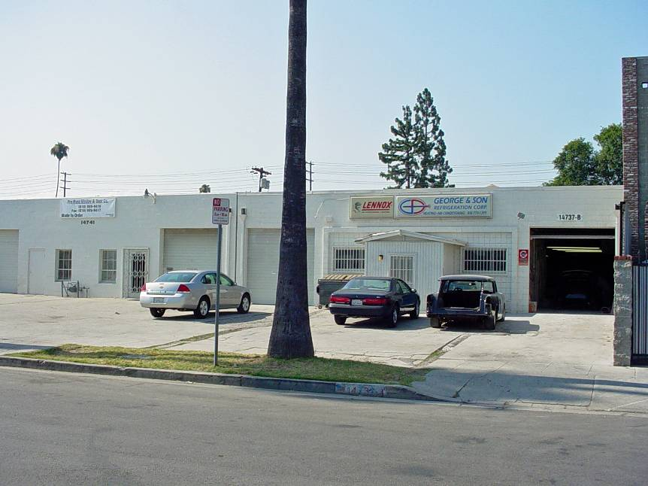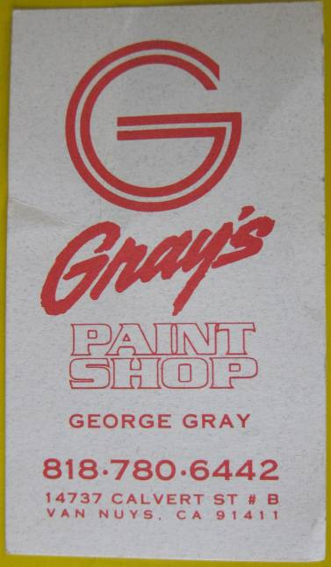
Dear James,
A short note to let you know that I took a trip to Van Nuys, and Palmdale, CA. My main purpose was to visit Nelson Schlaff, your fathers technician from 1981 to 1982. In the process I drove by 14737 Calvert Street to photograph the building where it all started. Your cousin George Gray was there and I talked to him for a few moments. He also showed me a number of interesting photos from January 1973 where a Japanese group was signing a letter of intent. Apparently, the deal fell through. George claims that Marvin Cole, in his opinion, was the source of the technology. I called him when I got back to Spokane. He said he "didn't want to get involved". So much for that source. It seems that George mentioned that he owed your father a great deal of gratitude. I can certainly understand his position and respect his wishes.
My two day discussion with Nelson Schlaff (age 66) reveled that your father withdrew his technology from 1979 to 1987 for unknown reasons. Nelson's job was to get the motors and "popping coils" to operate on classical electricity. It eventually took 5 times as much energy to do the same things they did in the 70's. It seems that your father built one and only one CSET in 1986. It appears that this was the last non-classical converter ever constructed. Your brother Mark claims that he heard a rumor that the technology was sold in 1979. He doesn't know to whom.
Nelson reports that he went to work for Mr. Russell Audrey of Dodge City Kansas after your father's death. When he was there he reported that several of the motors, the "Trigger-Cart", and a huge portion of the spare parts were in the shop that he worked in. This is where the last surviving motors were discovered in 2000. I have a few phone numbers and I'm following up on finding out what events took place there. The people I have numbers for don't answer their phones very often (if at all).
I hope you are recovering well from your medical procedures.
Mark McKay <<DSC02543.JPG>>

Dear Mark,

I am so grateful for this photograph of my father's (now George's) business building!

It's the first I've seen it since 1970-71 . . . I was overwhelmed to tears for some reason!

I know tis a lot ask of you, but if possible, could you send me a copy of your original
so that I may frame it and place it in my office? Your picture has a flurry of memories
and emotions running through my heart and mind! Most are very sweet, some unfortunately
bitter! But all-in-all, they are worth revisiting!

Again, thank you so much for sharing your efforts!

Mark, tomorrow I'll respond to this letter . . .

Sincerely,

Dr. James A. Gray, Sr.
"Prayerful Solutions!"
Christian Counseling Services
1335 North Caddy Lane
Wichita, Kansas 67212
(316) 641-7029 (c)
(316) 721-5104 (h)

Fri 7/20/2007 12:27 PM

Hi Mark,

Just a heads-up on a Mr. Gary Vesperman from Henderson, Nevada.

He has an honest interest in knowing technical info regarding my father,
his invention(s), etc.

He is also the Co-Owner and Director of Research for the Blue Energy
Corporation plant located in Henderson, Nevada. His e-mail address
is: www.blue-energy.us

I believe you and he may be able to help eachother . . . it's your call.

It appears that he has tremendous background in an area you've
questioned me about, but I couldn't meet your needs on the intellectual
and technical level.

Anyway, I've shared with him your e-mail address so you two can decide
the depth of assistance one can be to the other!

I hope you are not offended and/or upset with my decision, its just that I
felt it would be best for you to talk rather than for me to be a "go-between"
with my lack of effective knowledge in what he would like to know and
accomplish.

Sincerely submitted for your edification and consideration,

Your friend . . . James (God-Bless-You)

Dr. James A. Gray, Sr.
"Prayerful Solutions!"
Christian Counseling Services
1335 North Caddy Lane
Wichita, Kansas 67212
(316) 641-7029 (c)
(316) 721-5104 (h)

From: Gary Vesperman
To: Mark McKay
Cc: Dr. James A. Gray Jr.
Sent: Tuesday, July 24, 2007 11:39 PM
Subject: Do we have a genuine suppression case with Ed Gray?

Mark,

Thanks so much for your many comments on the raw draft of my Ed Gray suppression story.

I read over your remarks twice and the timeline once again. I could not find any solid instances of possible suppression. There is this one:

"Gray's problems began last July 22, when L.A. authorities raided his plant in Van Nuys, CA. Virtually everything in the building was confiscated --- including his working prototype motor.

Seven months later, not a single charge has been brought against Gray. Yet, the L.A. District Attorney's office still has his records and engine models.

The Van Nuys raid is only the latest incident in a strange pattern of "non-arrests" of automotive inventors that dates back more than half a century."

But Nelson claimed that much of it was returned to Gray except the 9-pole motor.

I suppose I could write a half-page story around that incident, and let readers dig for themselves the whole messy story. You know far more than I do. Is this one incident a genuine suppression case? Or is it just an overworked DA office stumbling along? The LA DA's certainly weren't concerned about conservation, environmental protection, etc.

Gary Vesperman

Wed 7/25/2007 10:07 PM

Dear Gary & Mark,

Here's some irony regarding your piece below!

Two years ago a very special friend of mine died of esophageal-cancer, his name was Rev. Eugene Moreland. This wonderful human-being was the Pastor of the College Hill Baptist Church located on the north end of San Bernardino, California. It was his message on John 3:16 that made me realize I needed Jesus in my life! In fact, it was the second Sunday of hearing his powerful Tulsa, Oklahoma styled preaching that brought me to my knees before God!

Immediately, my wife and I joined this lil' church, and in so doing we met his wife and children. I was in my mid twenties, his children were 4-5 year before me (near 30). They were a good family. One of the children was a fellow by the name of Mike. Mike worked for the Riverside, California police department, he was in his early years as a policeman.

Let me move ahead just a bit. Pastor Moreland, Mike's father, on a visit just prior to going home, shared with me a fabulous story of a man who had this wonderful invention! He was so captivated by this machine that he and hundreds of other Southern Baptist ministers unloaded millions of their hard earned retirement accounts for stock in this exciting invention! This was done back in the early to mid 70's in the states of California, Idaho, Arizona, Colorado, Nebraska, Kansas, Missouri, Arkansas, Iowa and many other interior states! In the Dodge City area of Kansas one church alone purchased 1.5 million dollars into Zetex and Zemex stock.

Now here's the irony of this story. I knew nothing of these folks business venture with this man and his invention until 33 years later, in my home here in Wichita, Kansas! Furthermore, Pastor Moreland and I had never connected the fact that this man of promises of untold wealth was . . . my father! I'm not finished yet! The arresting detective of the Riverside, California police department was my friend, and Pastor Moreland's son . . . Mike Moreland! It appeared that Mike's attempt to disrupt my fathers plans caused quite a rift in this family unit! You see, this sincere father and man-of-God saw the potential in my father, while his son was being influenced by unknown subjects to squash the "EMA" program and render my father a fraud! But he failed, my father was legitimate after all!

This story has never been told before simply because I hesitate to corrupt anyone person's image, after all, there is almost always two sides to every story/event, etc! Each of these men were/are good men, but with different perspectives!

Sincerely, James . . .

Dr. James A. Gray, Sr.

From: Gary Vesperman
To: Dr. James A. Gray Jr.
Cc: Mark McKay
Sent: Thursday, July 26, 2007 9:09 PM
Subject: Call Mike Moreland?

Jim,

I have a couple of dandy small-world stories myself.

Maybe you should call Mike Moreland and ask him if knows whether the SEC actions regarding your father were arranged by secret US Government energy invention suppression bullies.

Gary Vesperman

Gary,

I already know the answer to your question.

The attack upon my father and his invention were spurred by local politicians
jockeying for favor and higher position, and further exasperated by lobbyist and
FBI agents who were basically carrying out the wishes of scorned big oil entities
of that area: Union 76, Standard & Mobile! Mike, in my opinion was bucking
for deeper roots in law enforcement. Though I continue to communicate with
Evie Moreland (Gene's wife), and Mike's mother, He I have not communicated
since that time frame. As a final thought, I have attempted reacquaintance with
the Moreland siblings, but to no avail! I quess they take a bit of stock in the
axiom: "The apple doesn't fall far from the tree." In essence, it's fair game to
assume that an offspring of Edwin Gray's isn't worthy of further association
because of the great loss of their parents life-savings! Personally, I can understand
this, I know how difficult is to raise a family on a local Pastor's salary! Too many
folks feel don't realize that these men live by faith . . . they are not TV evangelists!

However, after an 1 1/2 hour lunch and power nap, it has come to me to speak with
Evie Moreland, and see what she can tell me about her son's motivation for attempting
sensure my father's efforts. I make no promises, if I'm able to secure any worthwhile
information . . . well, I'll share with you and Mark Mckay!

Sincerely,

Dr. James A. Gray, Sr.
"Prayerful Solutions!"
Christian Counseling Services
1335 North Caddy Lane
Wichita, Kansas 67212
(316) 641-7029 (c)
(316) 721-5104 (h)

From: Mckay, Mark
To: Dr. James A. Gray, Sr.
Sent: Friday, May 25, 2007 7:05 PM
Subject: RE: Surgery Confirmation!

Dear James,

Attached is a first cut of a two page condensed bio on your father that I would like you to review when health and time permit. This will be posted on Dr. Lindemann's remodeled web site in the near future. It contains all the major events that you and your brother Mark have shared with me. I hope It will be an improvement over what was available before.

I would like to add your mothers maiden name, but I couldn't find it.

I hope your are in good sprits and have an effective plan to deal with your condition.

Sincerely,

Mark McKay

Thu 8/23/2007 1:29 PM

Hi Mark,

I am now in the process of sorting through a 35 business letter back-logue!
This is among them. I'm not certain to whether I responded to your query
regarding my mother's maiden name, nonetheless, here it is: Her "maiden"
name was/is "Curry", which had been reduced from it's original after her
father's parents were granted citizenship! Originally it was "O'Curry."

James . . .

Mon 1/7/2008 10:17 AM

Please pray for TUESDAY, it will be my day for all testing!

*PRAY especially in the affirmative for a GOOD REPORT on the C/T scans!

I am claiming the following two Scriptures form God's Holy Word for tomorrow
for the best results! Amen! The 1st speaks of "believing" in Jesus when He said:
"I tell you that if two of you on earth agree about anything you ask
for, it will be done for you by my Father in Heaven" (Matthew 18:19).

The 2nd speaks of the "faithful", to act by bringing their sick to Him . . . they will be healed:
"Jesus went throughout Galilee, teaching and preaching the good news of the Kingdom,
and healing every disease and sickness among the people . . . and the people brought
to Him all that were ill with various diseases . . . And He Healed Them (all of them)"!

Rejoice with me that God will bless all my results! PTL!

Dr. James A. Gray, Sr.

Dear Friends/Family,

Well we just came home, and I'm trying to get refocused!
Dr Johnson (Oncologist) spent quite a bit of time with us
detailing where I am, etc! As he revisited the results from
the past two weeks of labs and scans, he seemed puzzled.
He told us something didn't seem right. He went on to say
that the C/scan and Pet/scan didn't agree with former data
from the surgeon!

It didn't dawn on us till later that all the latest data says there
is NO cancer anywhere else in my body, with the exception the
lower esophagus and general area nodes! Why does this sound
odd? Because the surgeon told my family and friends that he
closed me up because he saw cancer "all over my interior"!
Again, the high-dosed C/S and the radioactive P/S showed
absolutely no other source of cancer incidents from my pelvic
to the top of my brain! You Take It from There! God Is So Good!

Also, the surgeon so noted treatment would be futile! Giving me
2-4 months on Earth! Not SO!
After Dr Johnson and two radiologists read, and re-read the scans,
they could not, did not find any further indicators! All my cancer
is contained in a general area! Also, they WILL be able to reach
the nodes between the pancreas and abdomen with radiation!
Though i am in stage 3 of 5, my prognosis for recovery is much higher!

Oh, one more thing, I start Chemo next Monday at 9am and I'll
be there all day. At the end of the day they will connect my
new metering pump. It'll will stay on me 24/5 (Mon-Fri)! On Friday I'll
return to the center for removal and blood-work. Then, I'm off for
two weeks! After that, we repeat the cycle for two more terms
(1-on, 2-off)! Then more labs and re-run the C/S and P/S again to
see how well things are going! If need be, this program can be
repeated 3 times! Dr Johnson doesn't feel the need will arise!
As always, all matters of life are in His hands and for His glory!

Dr. Johnson feels much stronger of the prognosis now! Keep praying!
Your prayers are powerful! Amen!

New Prayer Request: Pray that my system tolerates the powerful meds
I must now endure beginning Monday at 9am!

Always in Christ,

James . . . . . . .

Dr. James A. Gray, Sr.
"Prayerful Solutions!"
Christian Counseling Services
1335 North Caddy Lane
Wichita, Kansas 67212
(316) 641-7029 (c)

This was the last email I received from James. I didn’t bother him with additional requests for information. I figured when he recovered and was feeling he would again contact me. That event never happened.

Later, I learned from his wife that he passed away in 2009.

I am truly grateful for the brief time and conversation I was able to share with James. His honest disclosures helped establish the truth behind this interesting adventure and better sort out the few honest facts from the plethora of fictions.

Without Dr. Gray’s guidance I would have never been able to proceed with this research.

Mark McKay

